# EDS Exercise Activity – Performance Evaluation & Personal Brand Page Creation

## Objective:

This activity will help you:  
1. Evaluate the performance of an AEM Edge Delivery Services (EDS) website using Google Lighthouse.  
2. Create and open a personal brand page in AEM under the given hierarchy using a page template and edit it in Universal Editor by adding custom blocks.

## Part 1 – Website Performance Evaluation

Website Information:

- The website is developed using Edge Delivery Services with Universal Editor-based authoring.  
- Website URL: **https://main--aem-skill-up--guptapawan86.aem.live/**

Option 1:

1. Openhttps://pagespeed.web.dev/

2. Input site URL [**https://main--aem-skill-up--guptapawan86.aem.live/**](https://main--aem-skill-up--guptapawan86.aem.live/)

**3. click on analyse for both mobile and desktop**  
  
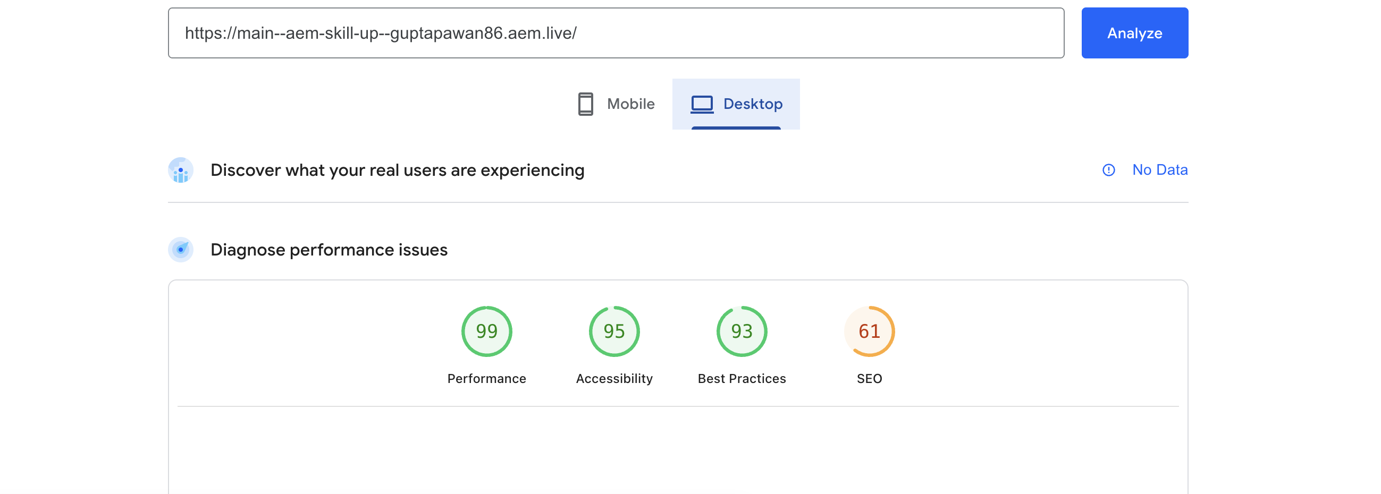

Option 2 :

Steps to Perform:

1. Open Google Chrome Browser on your system.

2. Navigate to the above website URL.

3. Open Chrome DevTools: Press F12 or Right-click → Inspect.

4. In DevTools, go to the Lighthouse tab.

5. Configure the report:  
 - Mode: Desktop (or Mobile– as per requirement)  
 - Categories: Select Performance (keep others unchecked for now).  
  
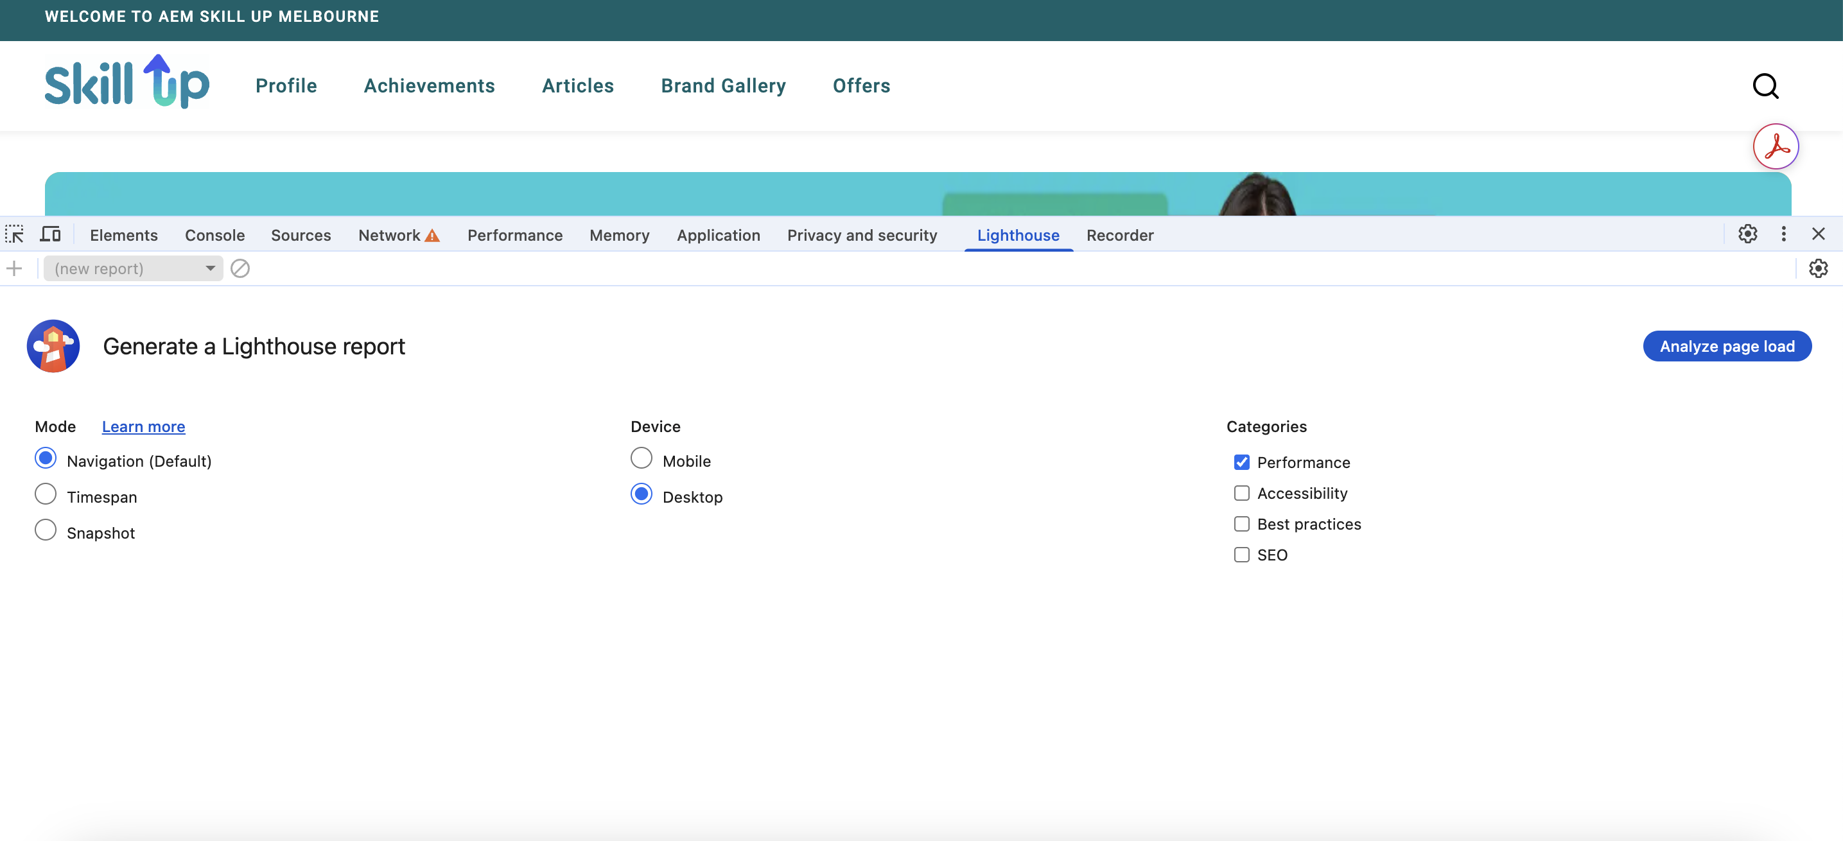

6. Click Analyze page load to generate the Lighthouse report.

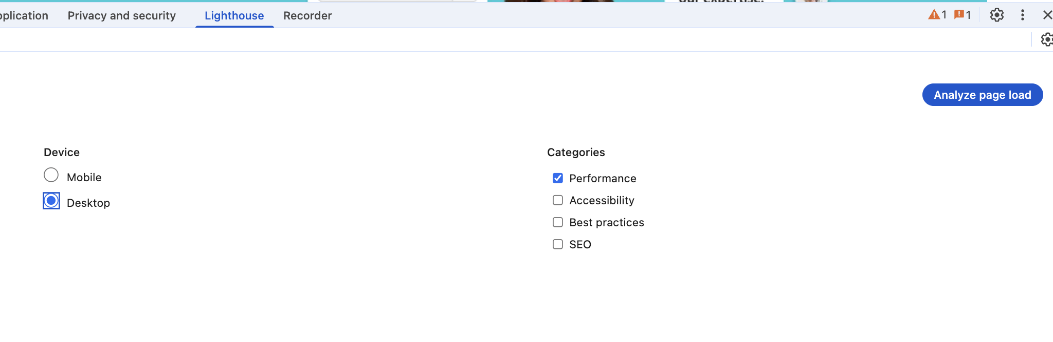

7. Review the Performance score and key metrics such as:  
 - Largest Contentful Paint (LCP)  
 - First Input Delay (FID)  
 - Cumulative Layout Shift (CLS)

8. Capture a screenshot of the Lighthouse report results.

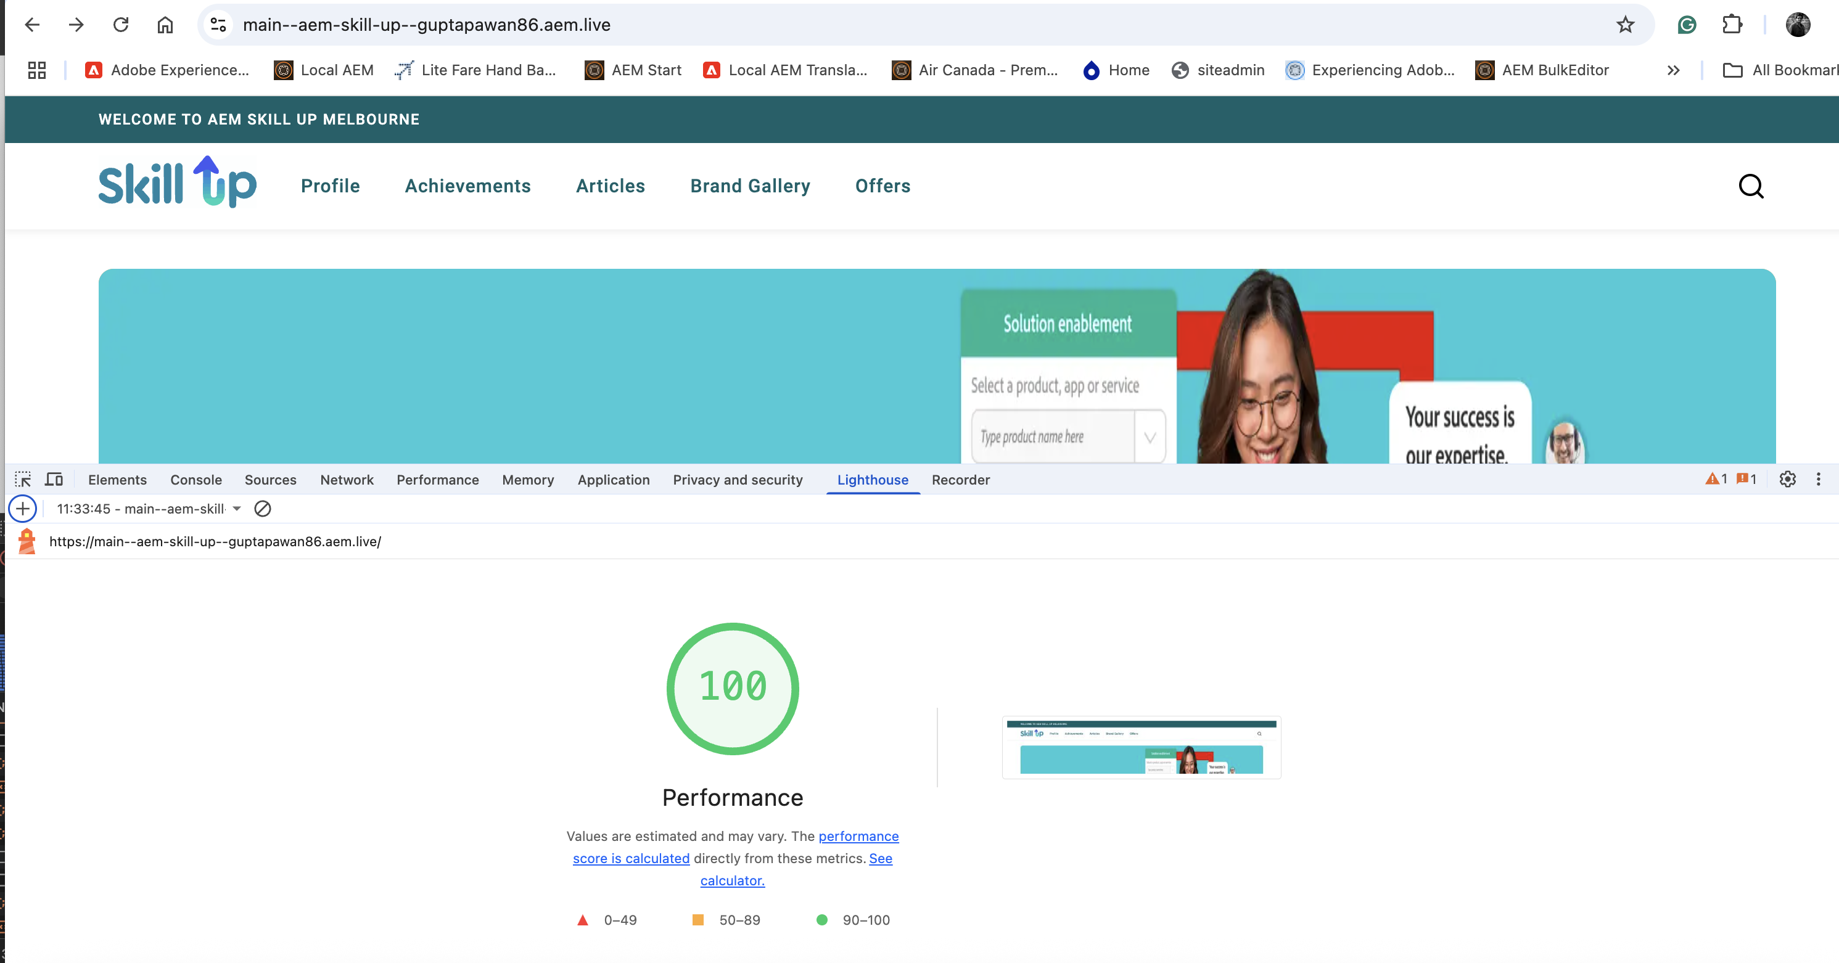

## Part 2 – Create and Edit a Personal Brand/Profile Page in AEM

1. Login to AEM Author: <https://author-p137117-e1400714.adobeaemcloud.com/>

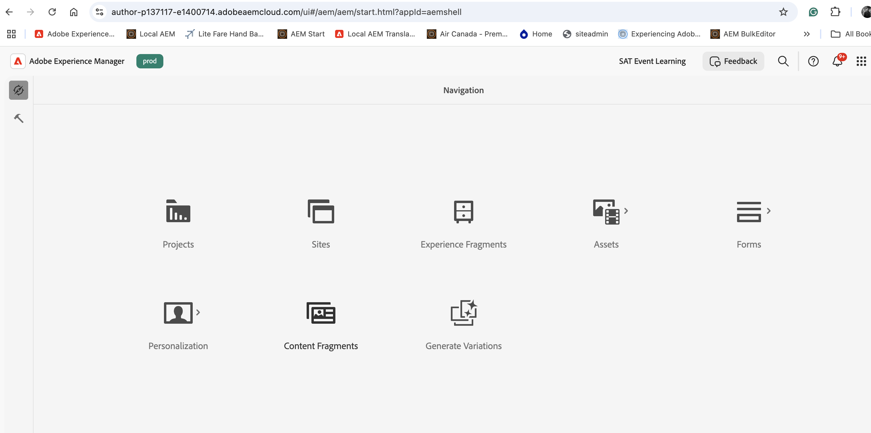

2. Select the Site Icon and go to the following path: /content/aem-skill-up/en/brand-gallery, or access it using the URL below.

<https://author-p137117-e1400714.adobeaemcloud.com/ui#/aem/sites.html/content/aem-skill-up/en/brand-gallery>

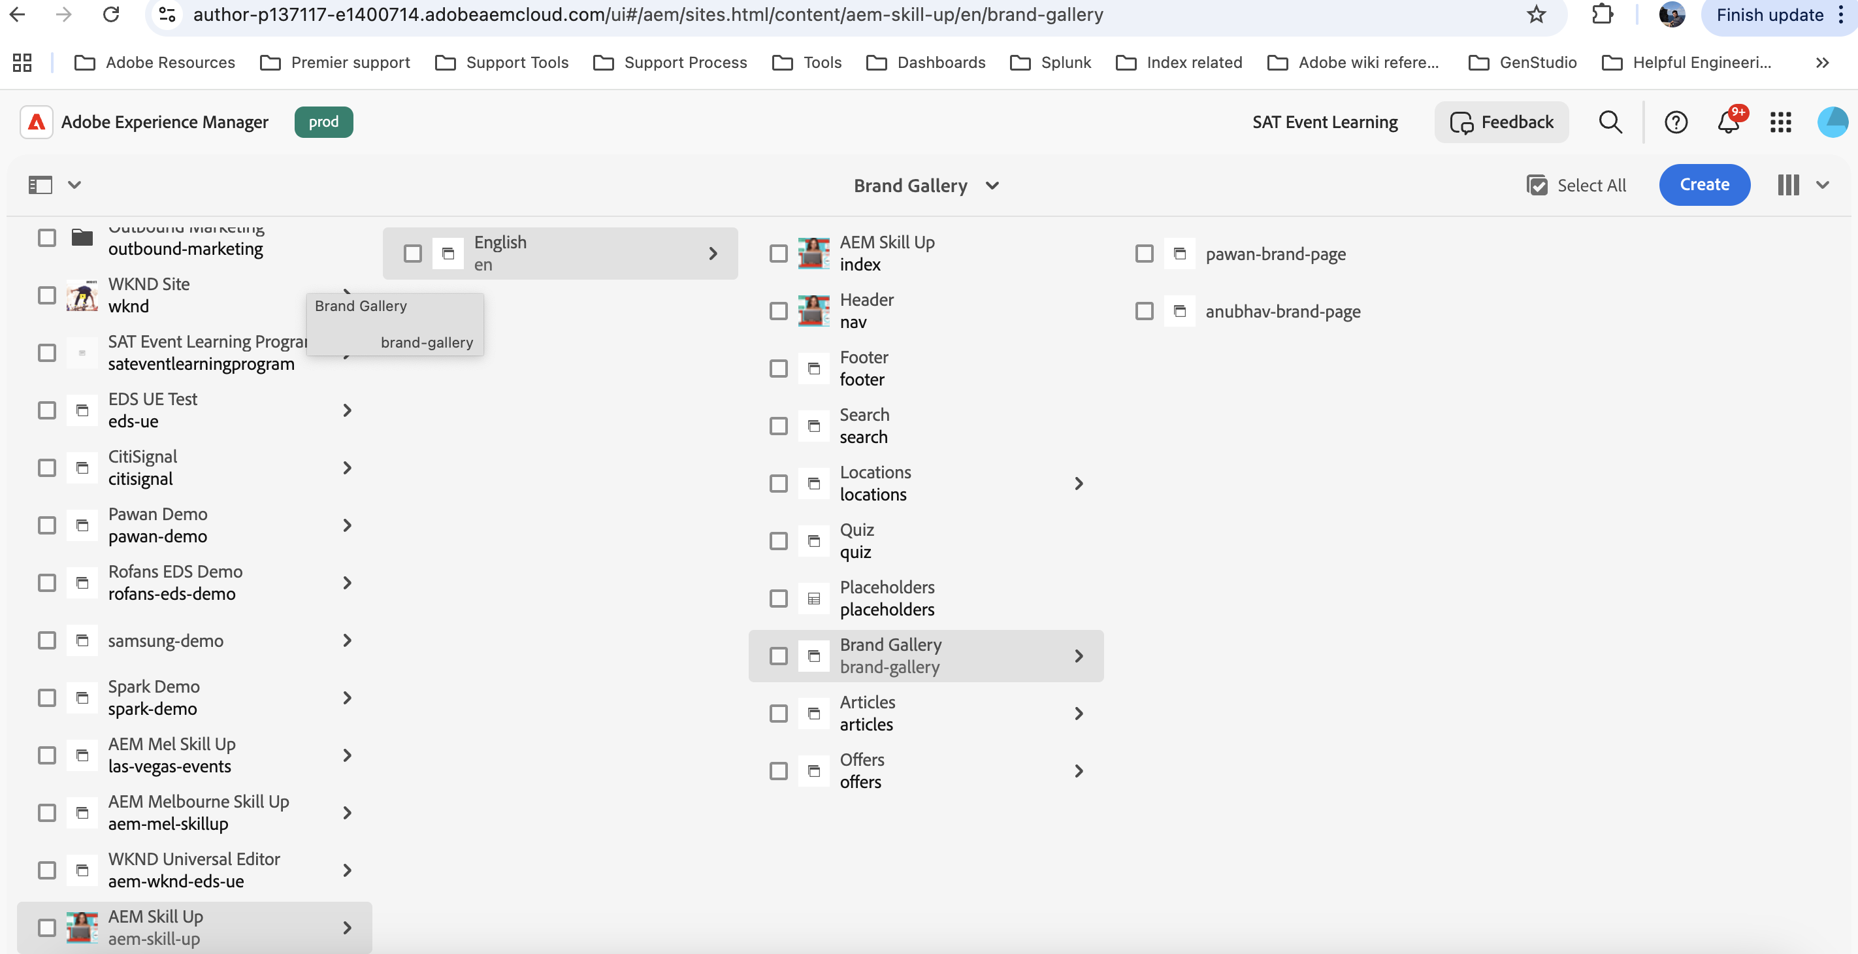

3. Locate the page “Sample Profile”

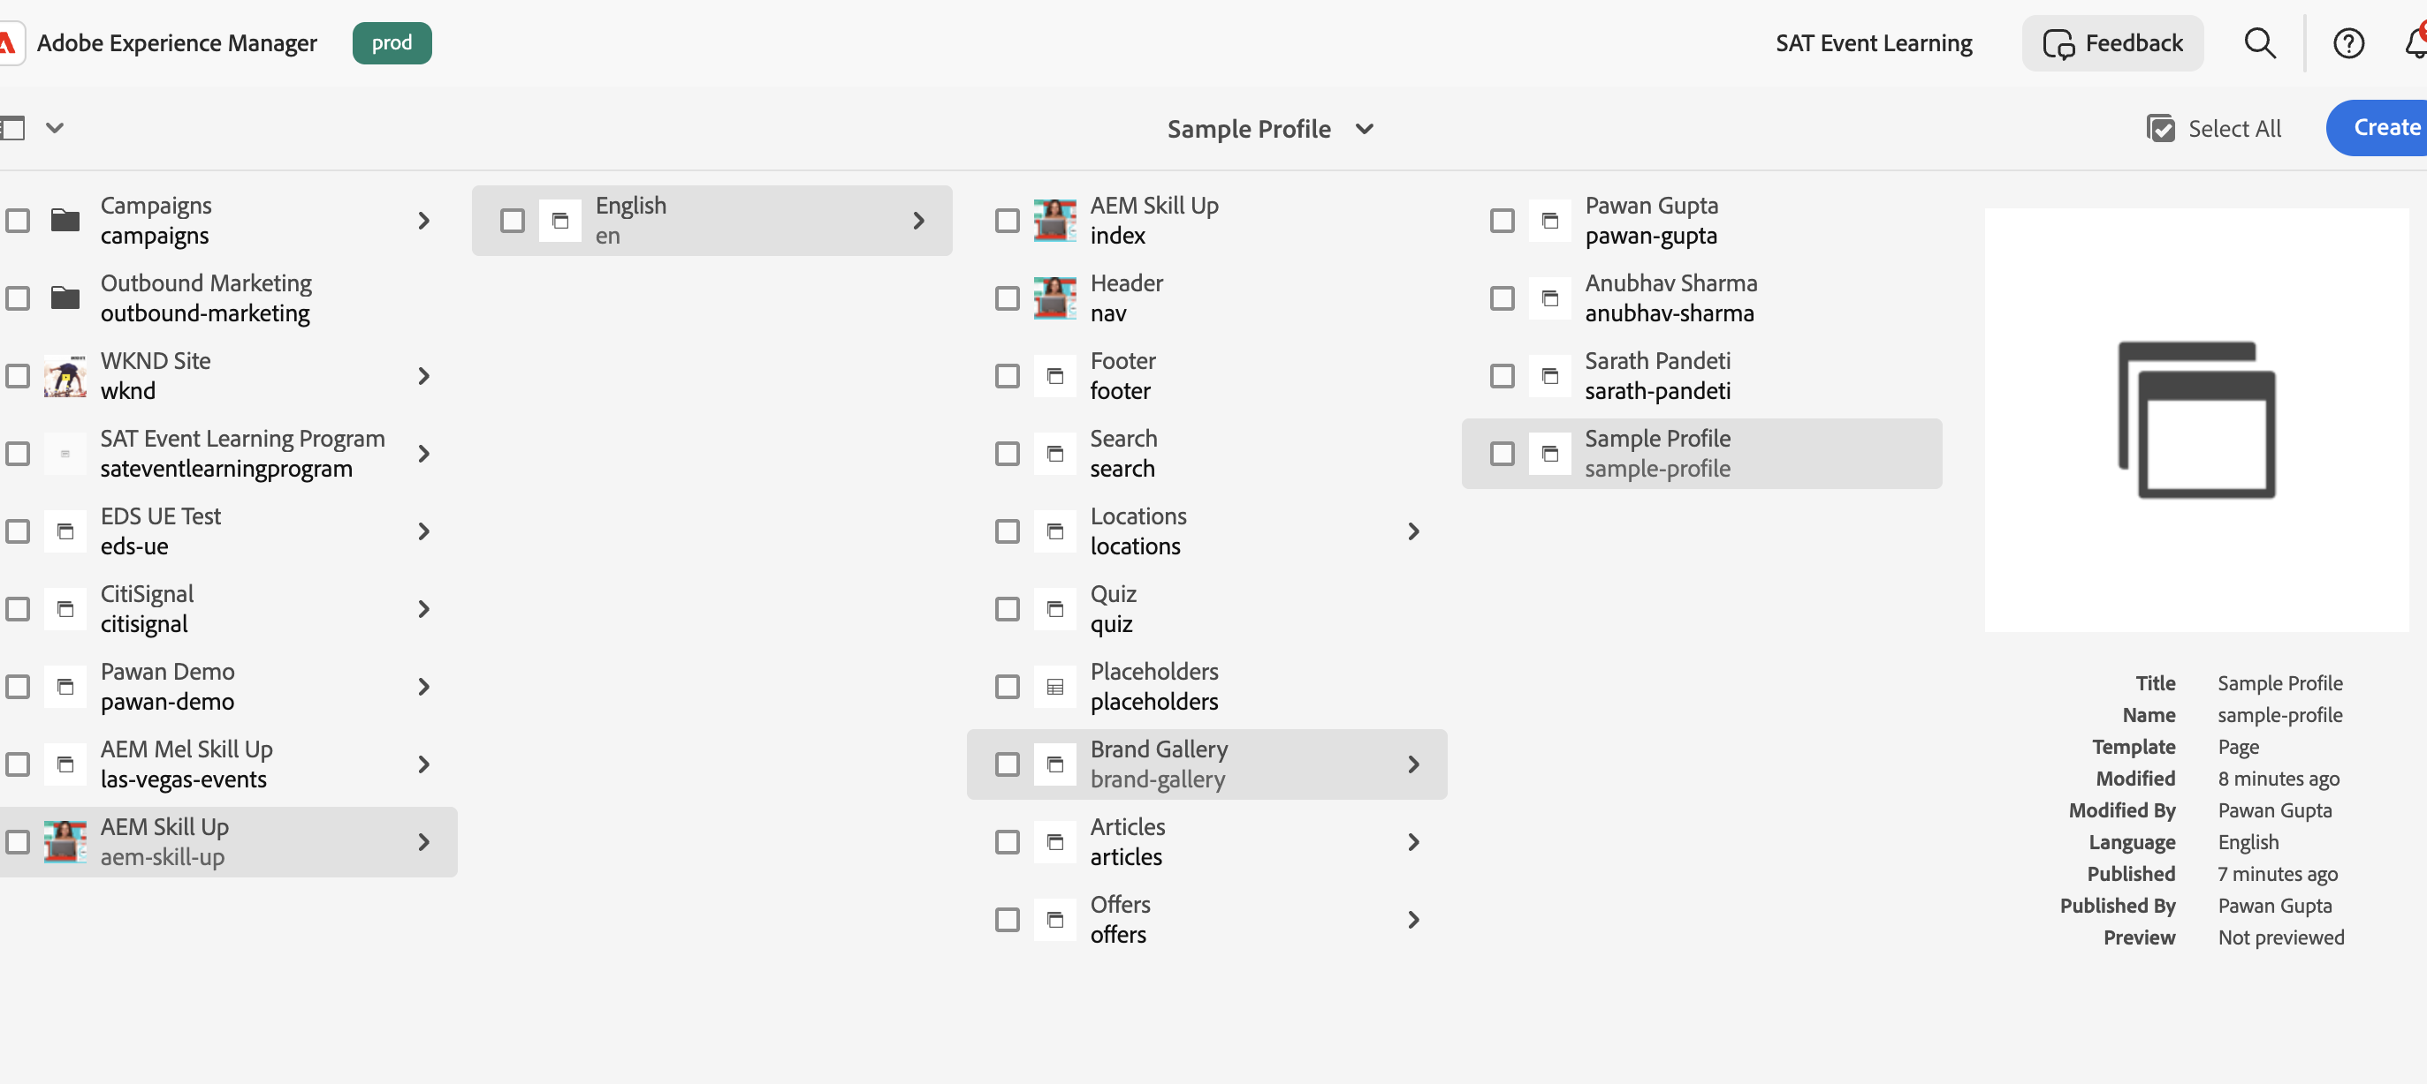

4. Select the page and copy the page using the copy option from the tool bar properties.

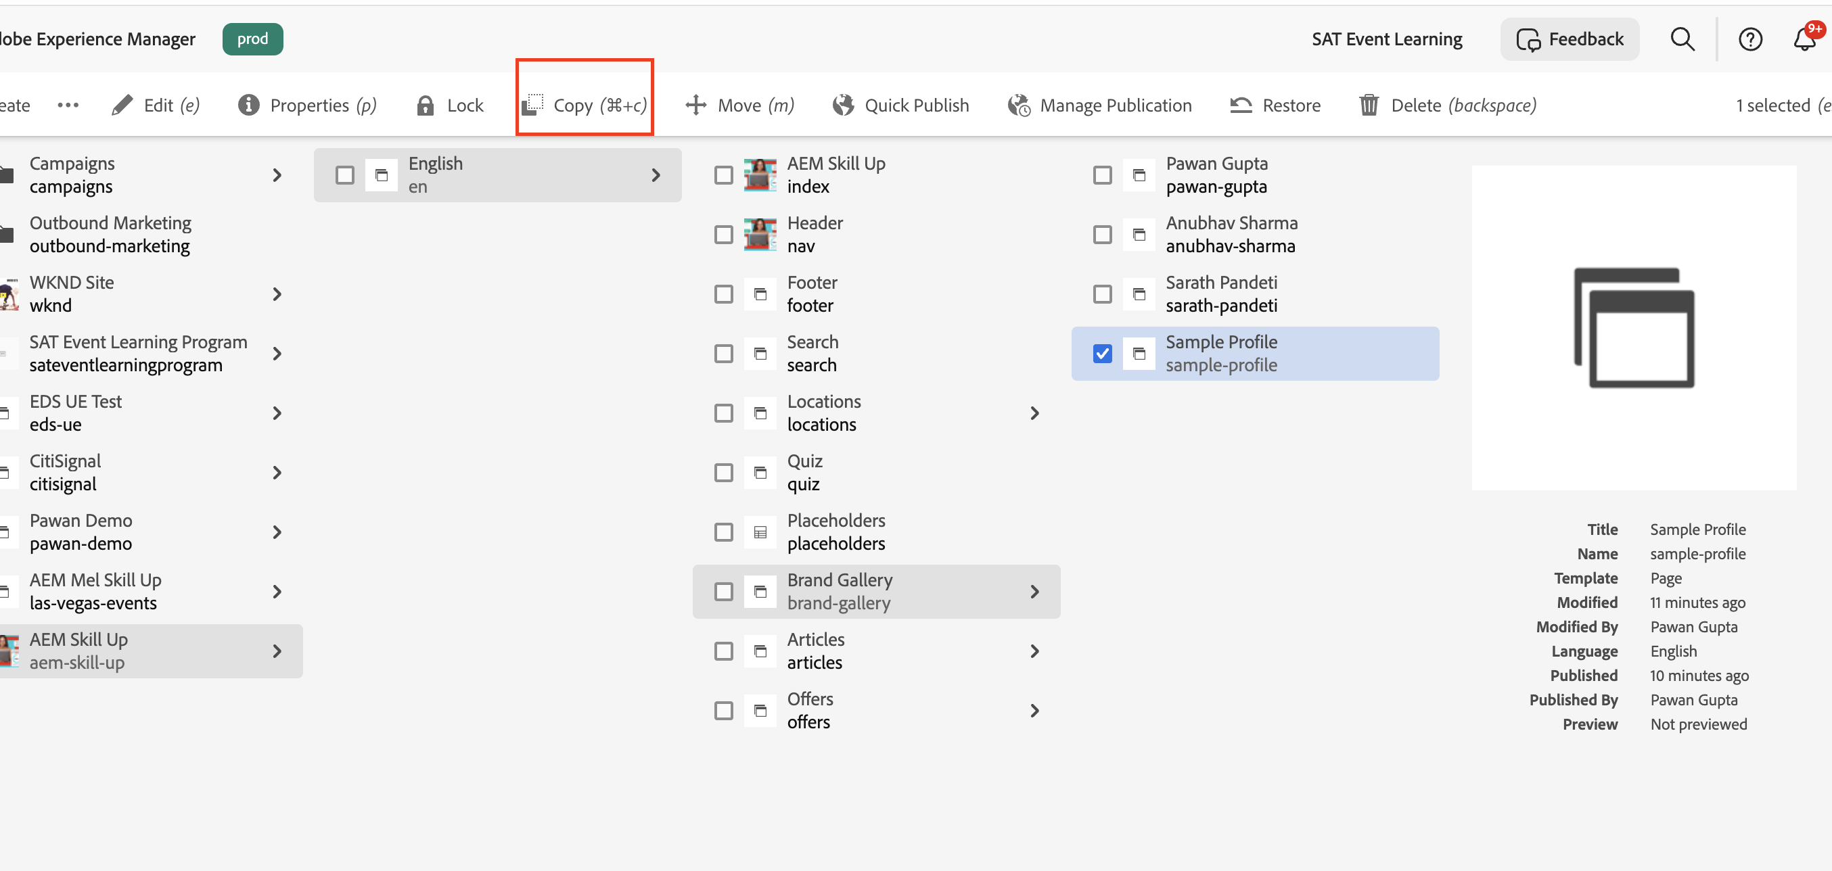

5. Paste the page in the same /brand-gallery hierarchy.

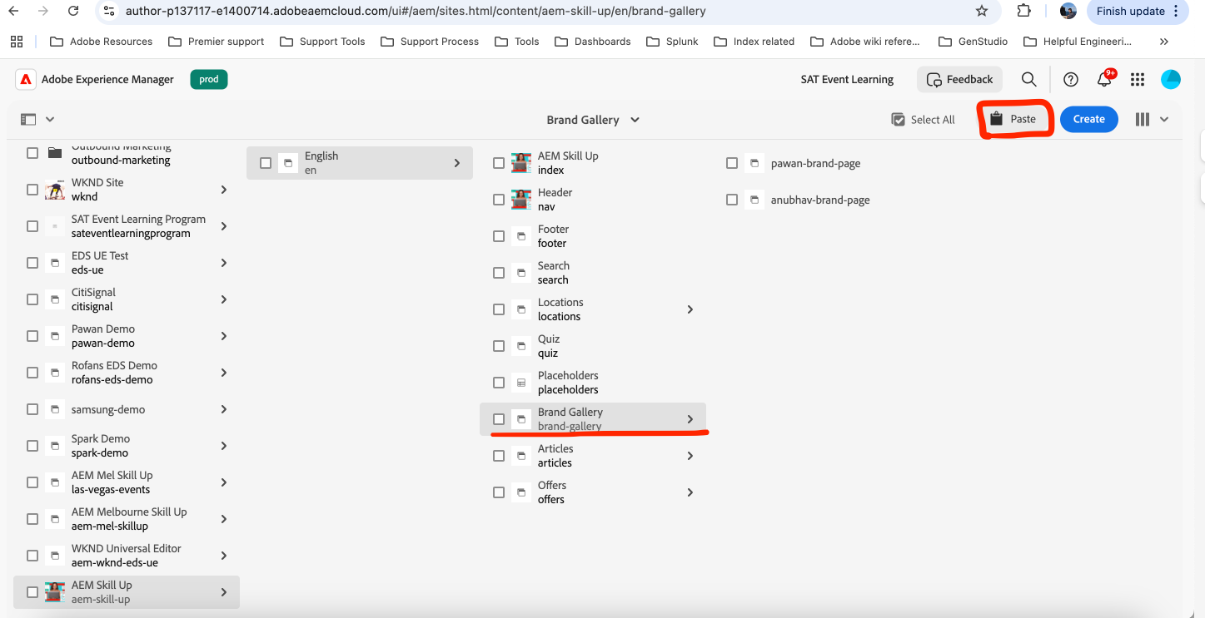

6. In the paste page window, set the New Site Name to your name (e.g., pawan-gupta), then click Paste.

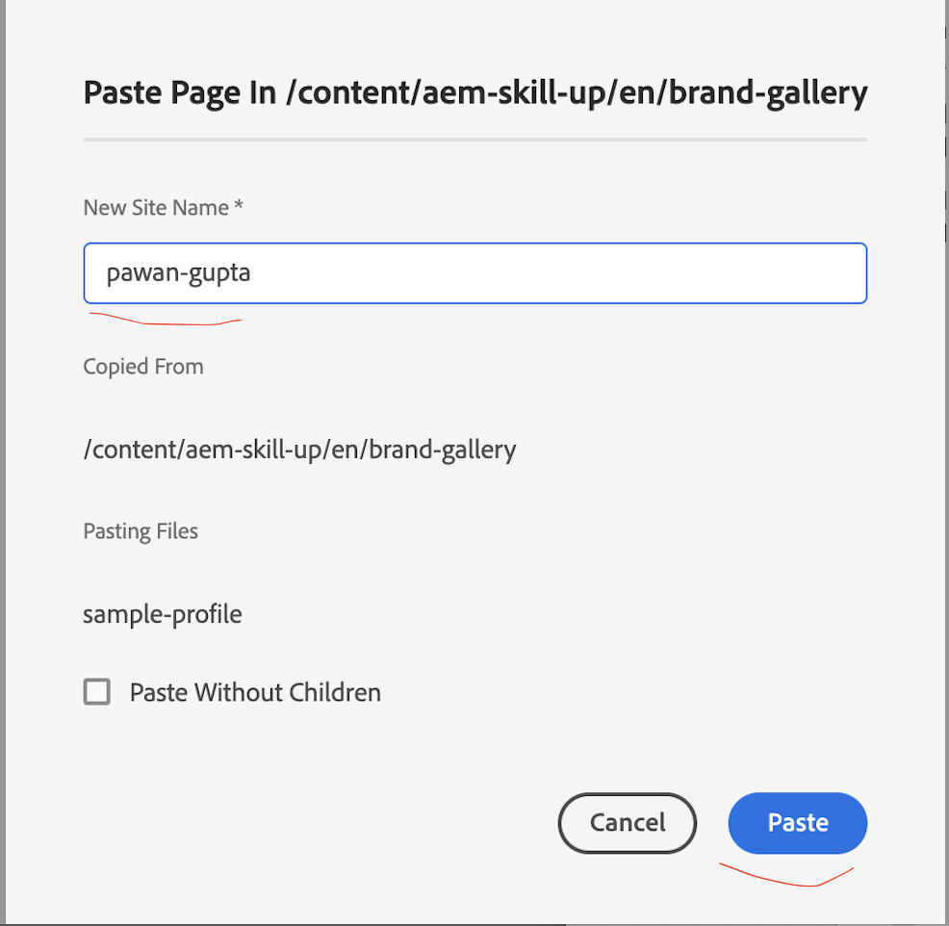

7. Select the newly created page and click on properties to update the title.  
  
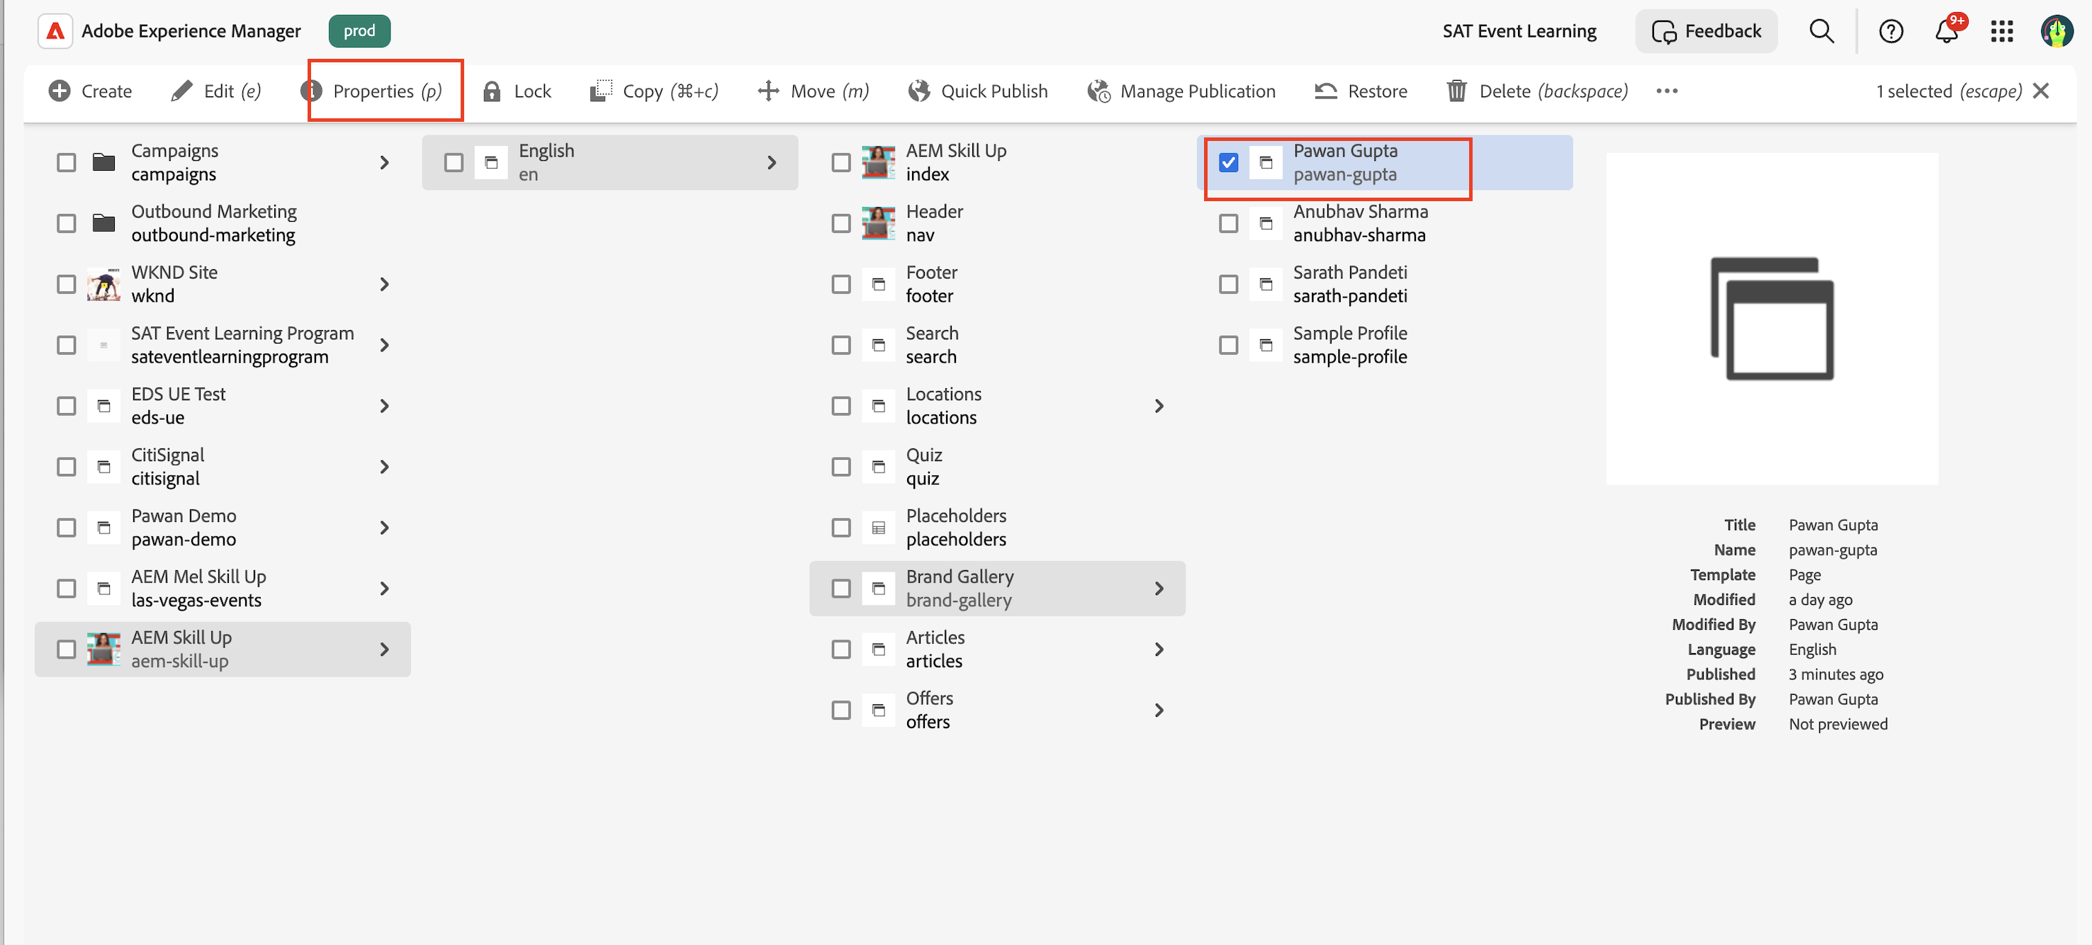

8. Update the title to your page (Ex Pawan Gupta) and click save and close.

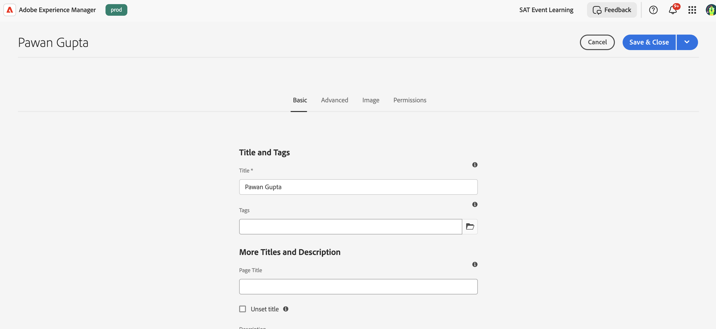

9. Select your page and click on Edit option in tool bar.

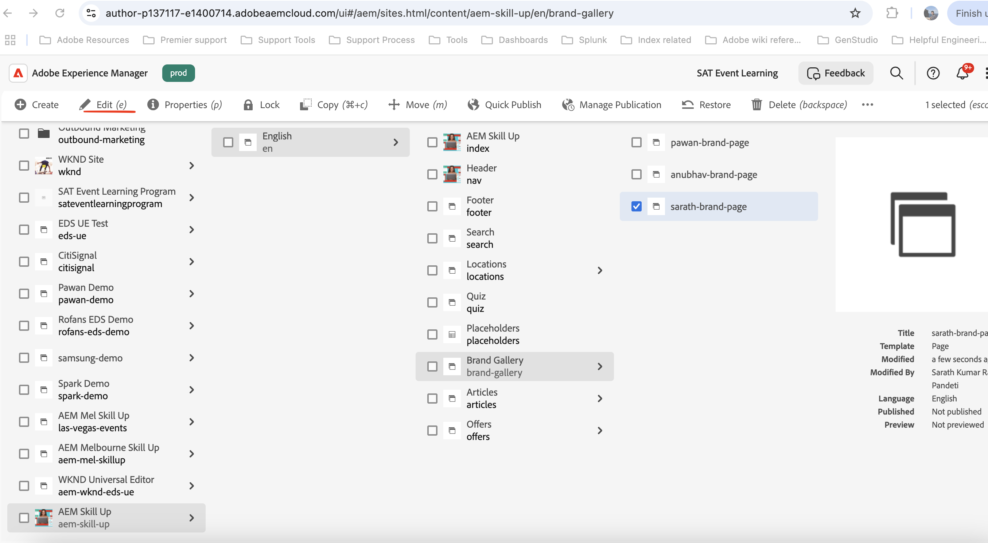

### Edit the Content

1. After opening the page click on the Content Tree option on the right side. It will list out sections in the page and corresponding included block/component

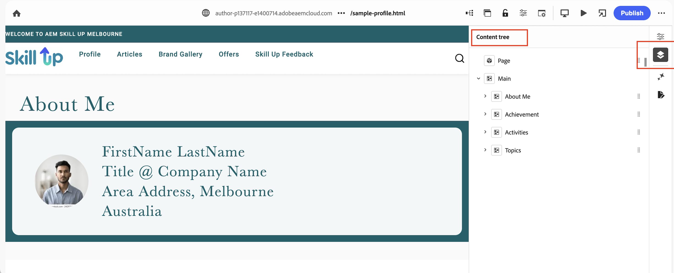

2. To update the content showing below “About me”. Expand the “About Me” in the content tree. It will list out Hero block having image and text field to update the content. To update content, select the field (e.g., image) and click Properties to edit it.

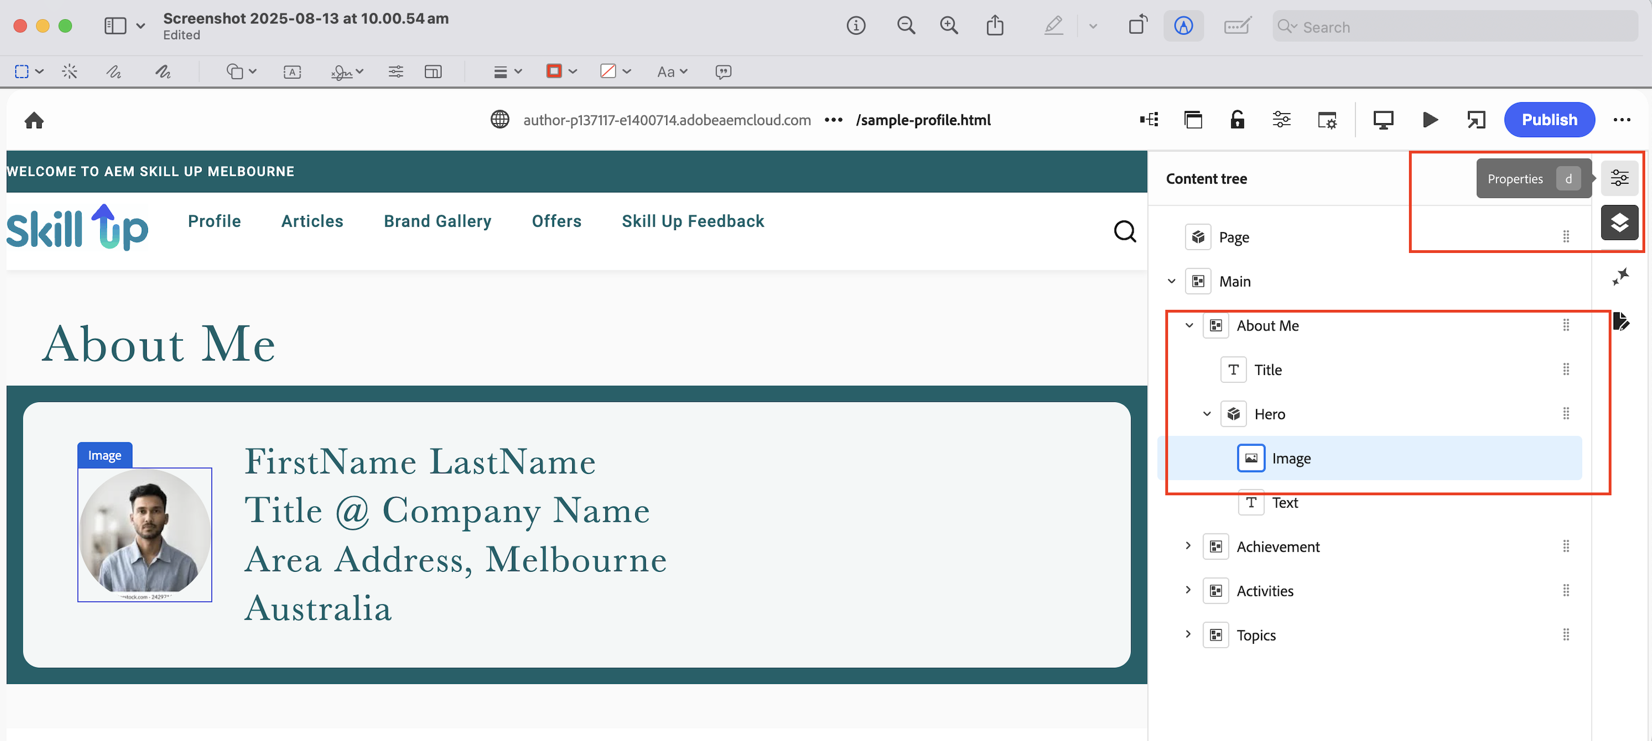

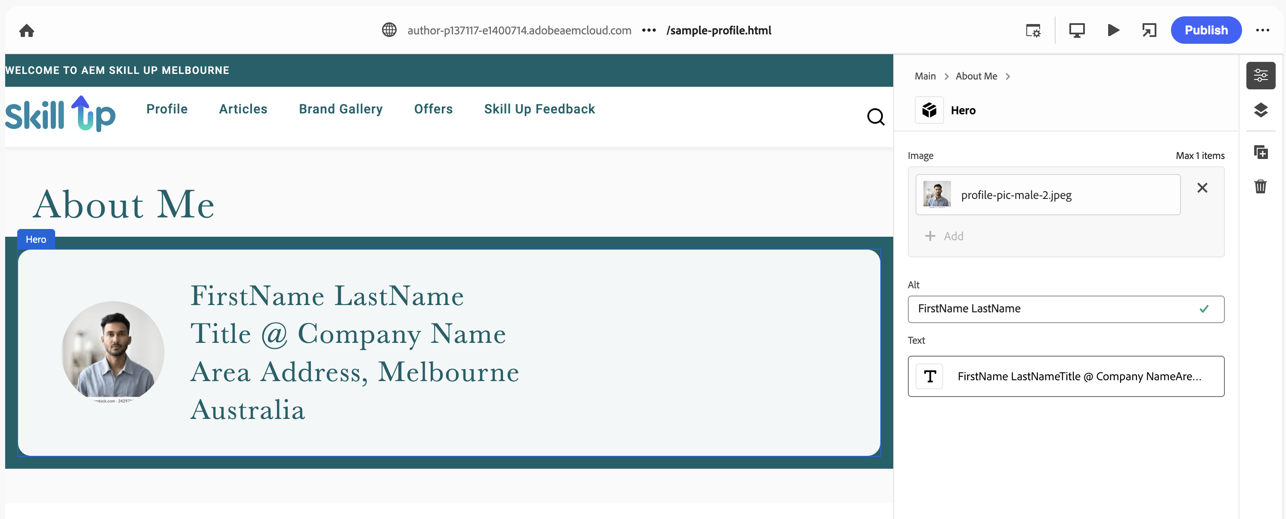

Note: To upload any image to be used on the page, please open to below [URL](https://author-p137117-e1400714.adobeaemcloud.com/ui#/aem/assets.html/content/dam/aem-skill-up/exercise) in the new tab

<https://author-p137117-e1400714.adobeaemcloud.com/ui#/aem/assets.html/content/dam/aem-skill-up/exercise>

Please create a folder using your name (for example: Pawan Gupta) and upload the images to your designated folder. In case you want to use the existing the image, refer to folder named sample (sample images) to pick the default images. For more details refer to how to upload assets section in the trailing document.

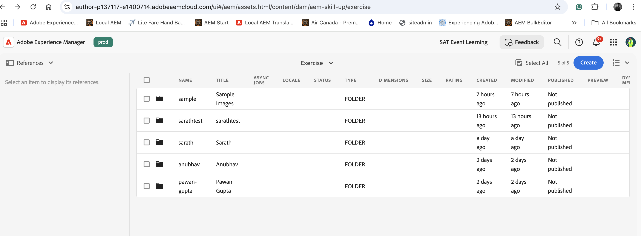

3. Moving further, data showing in **Achievements** section is getting rendered from content fragment where content fragment custom block component is making a call to content fragment API to pull all the content created using achievement content fragment model.

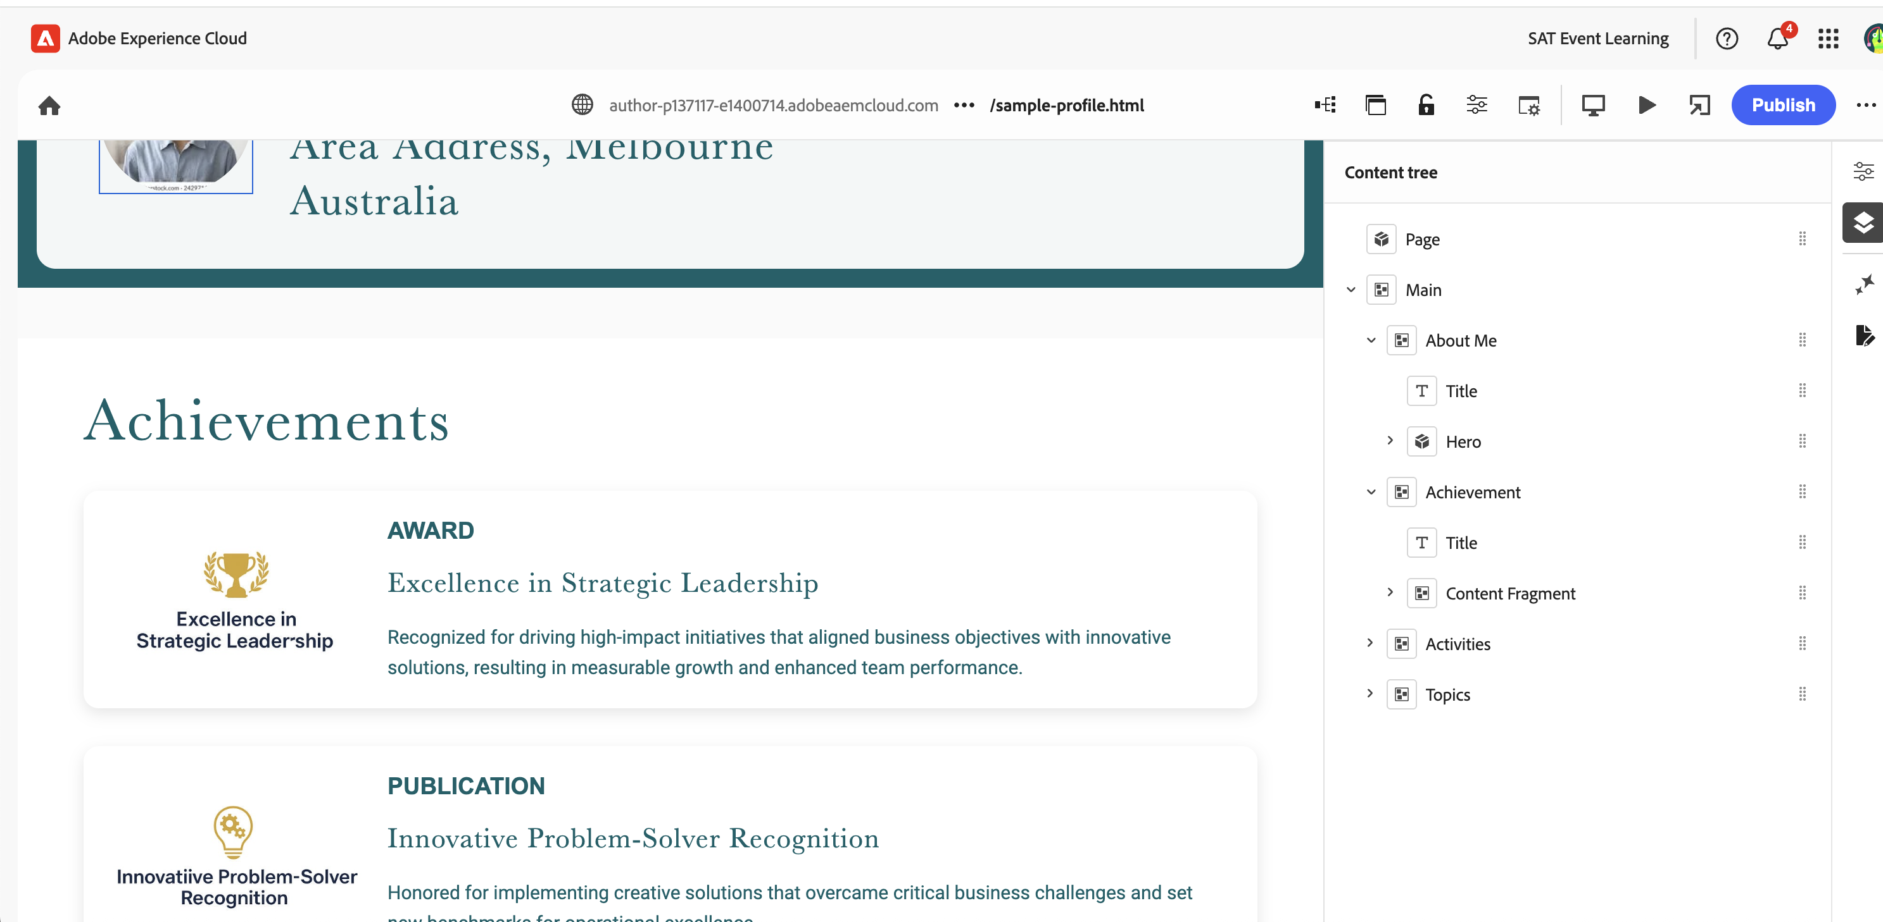

4. To show/create a new achievement record, navigate to your designated asset folder (e.g., pawan gupta) that you previously created by navigating link below.

https://author-p137117-e1400714.adobeaemcloud.com/ui#/aem/assets.html/content/dam/aem-skill-up/exercise

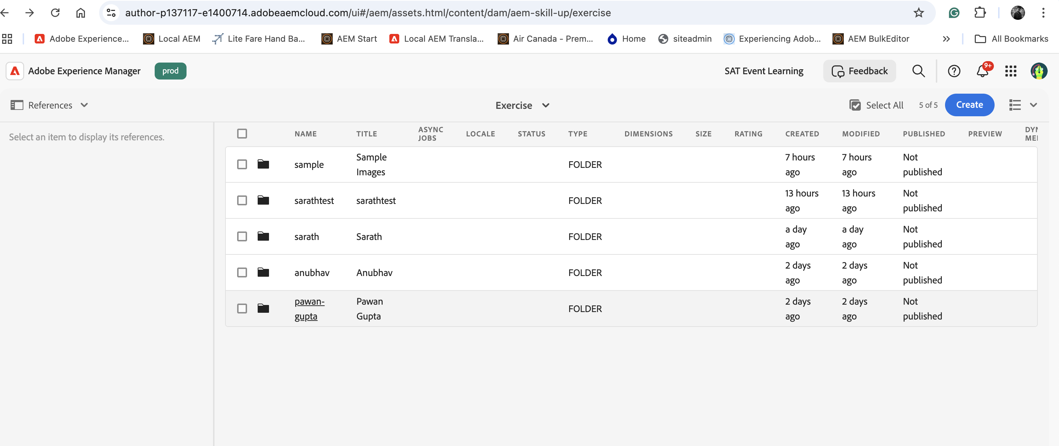

5. Once you have accessed your asset folder (for example, Sarath Pandeti), select "Create" and then choose "Content Fragment."

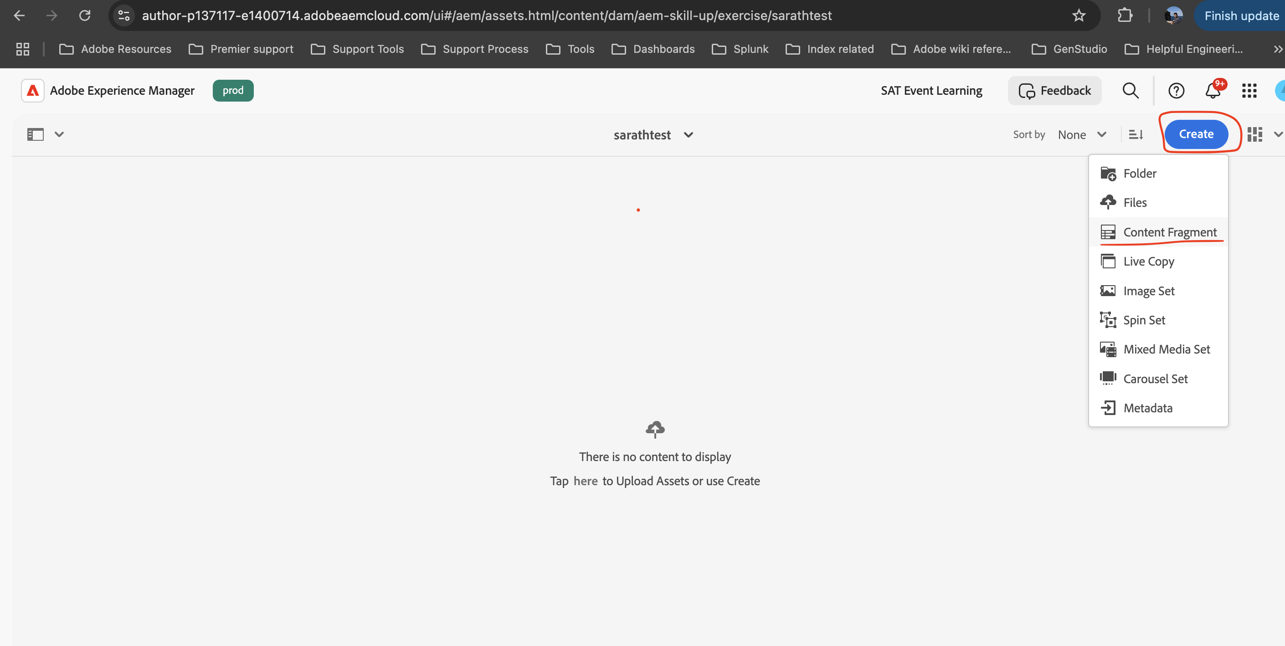

2. Select Achievement Model, click Next, enter the title (e.g., Sarath Pandeti Achievement), and click **Create.**   
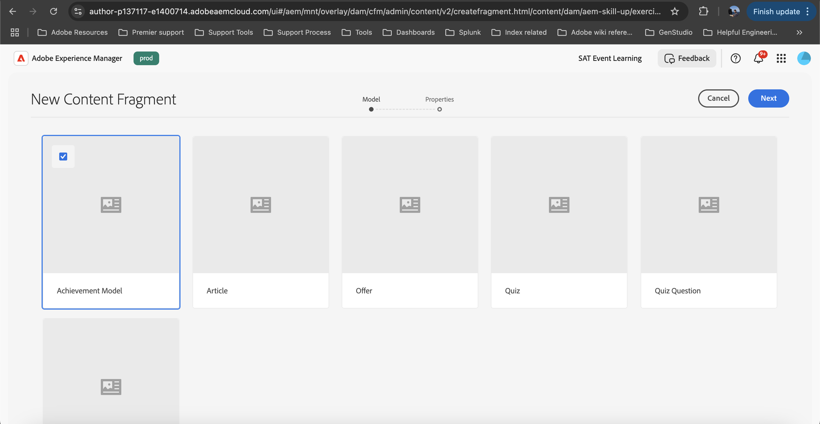

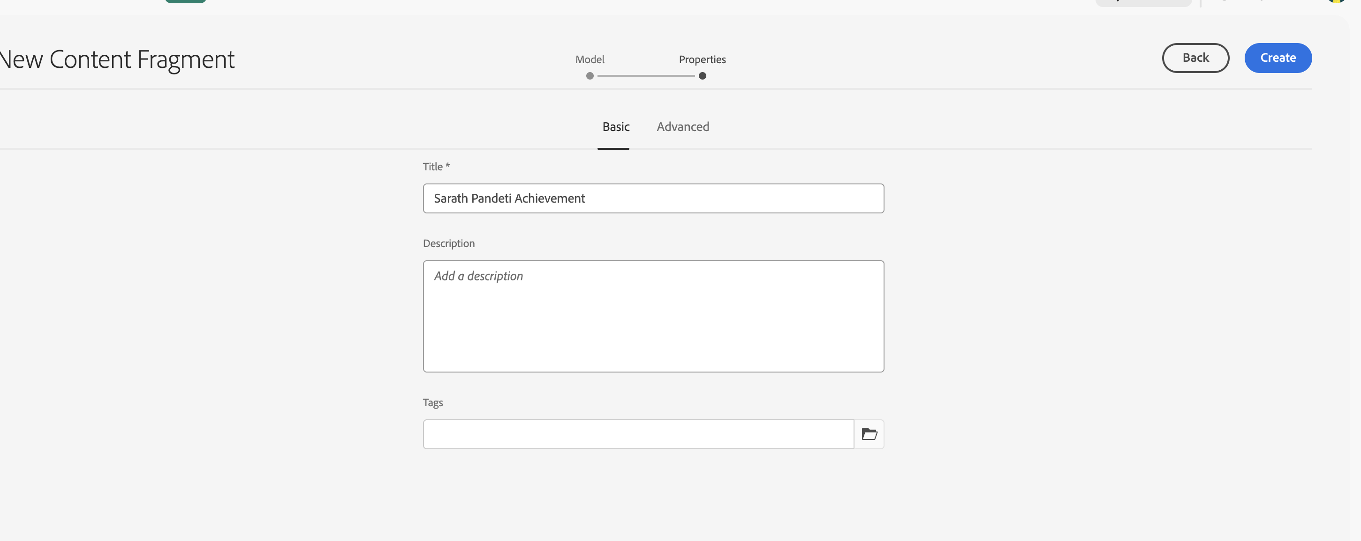

3. A Success popup will appear; select "open" to view the content model in a new tab.   
  
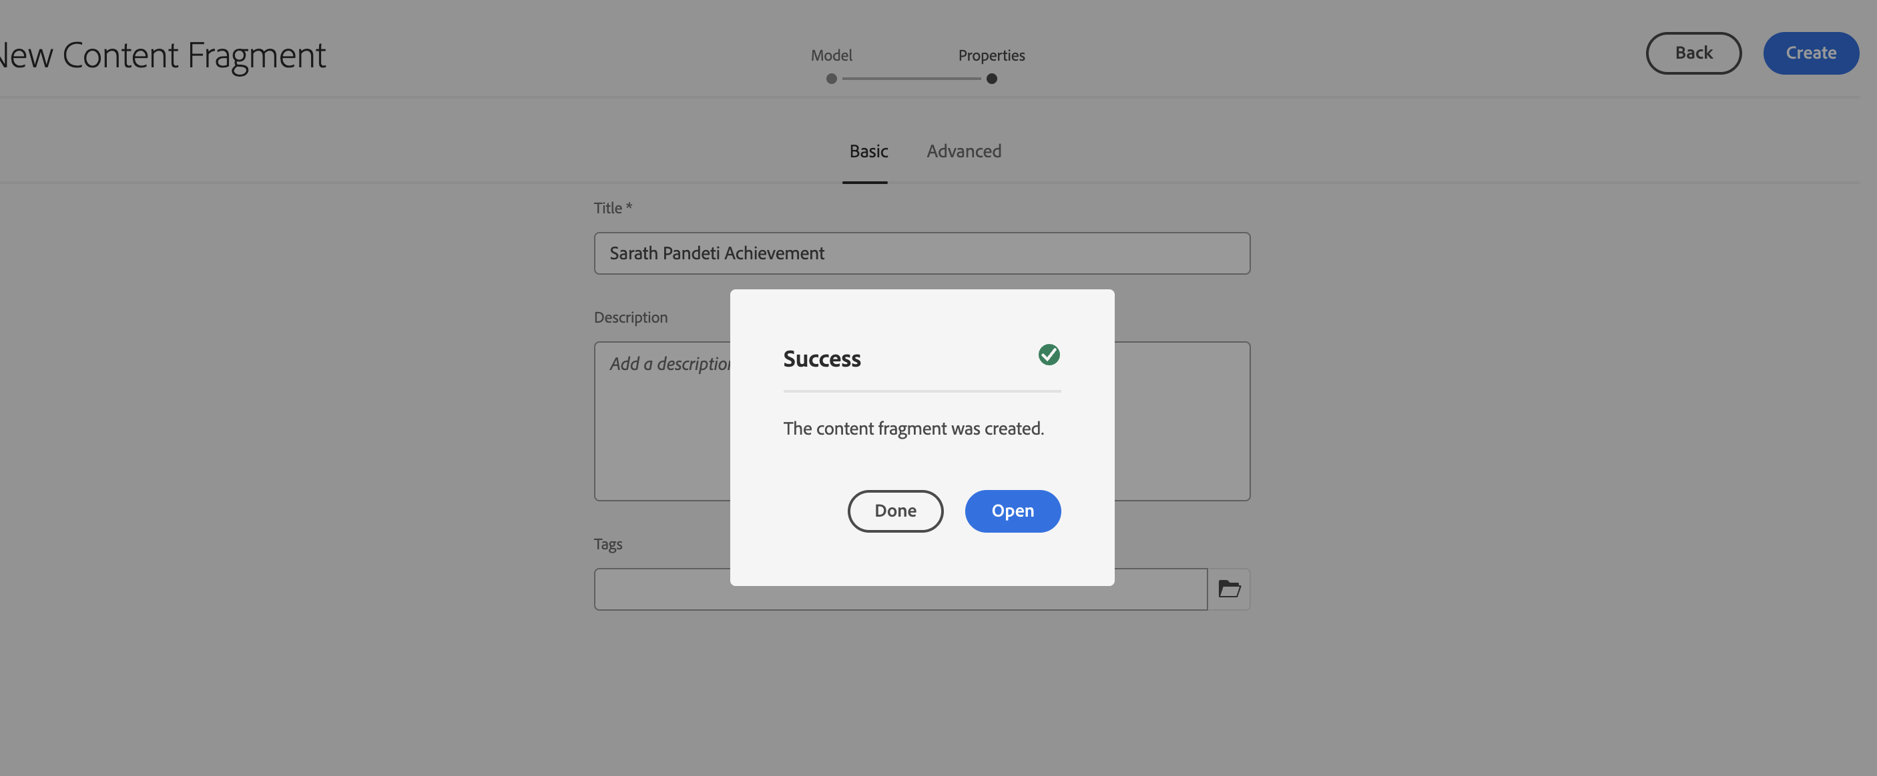

4. Please enter or update the Achievement Title, Description, and Achievement Image fields before clicking Save.

For Achievement Image field navigate to the assets folder where you uploaded the assets and choose an asset or use images present in [achievement folder under sample folder](https://author-p137117-e1400714.adobeaemcloud.com/ui#/aem/assets.html/content/dam/aem-skill-up/exercise/sample/achievement).

Sample content

Title -> Sarath - Excellence in Solution Delivery

Description -> Sarath Pandeti demonstrated exceptional expertise in delivering complex, high-value digital solutions on time and with outstanding quality. His ability to collaborate with cross-functional teams, anticipate challenges, and implement innovative approaches has significantly contributed to business success and client satisfaction. This achievement reflects not only technical proficiency but also leadership in driving impactful results.

Select category as you want

Image -> browser image under aem-skill-up folder -> exercise -> sample-> achievement by clicking on browse asset option in the field.  
  
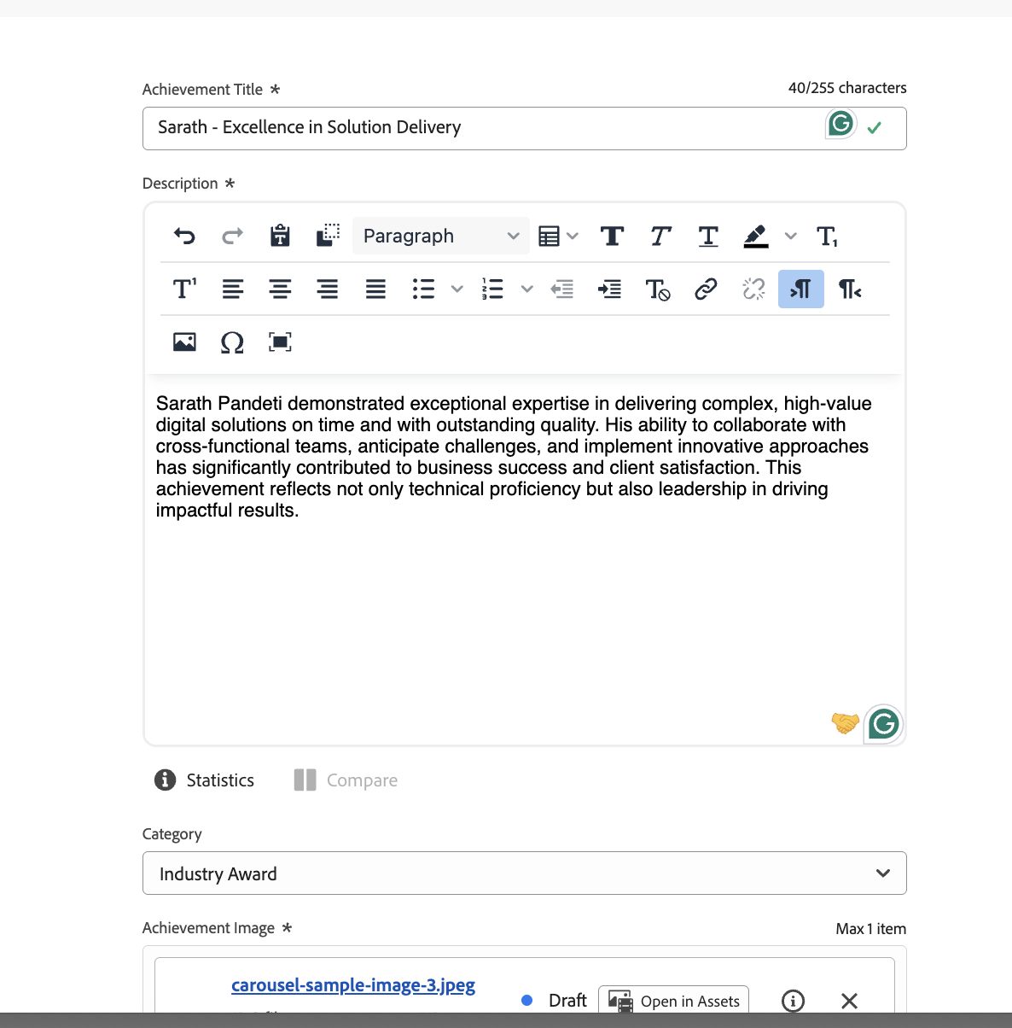

5. Click on **Publish** option after content is added.

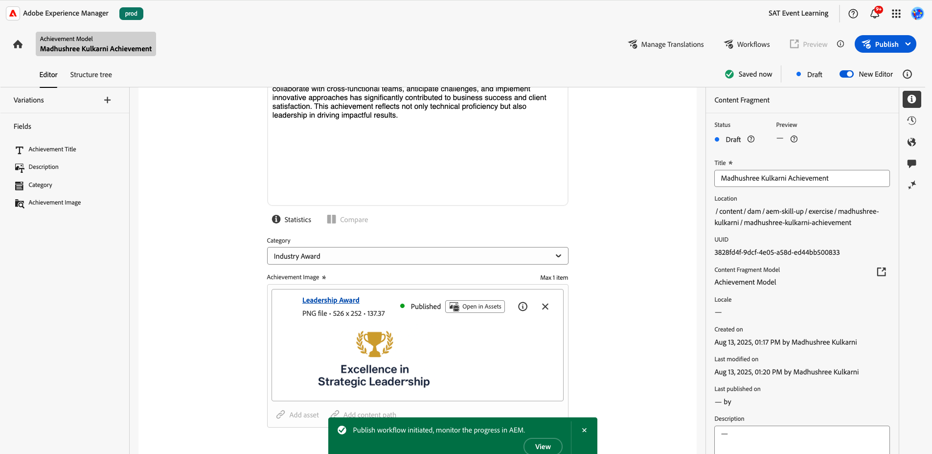

6.. Refresh or [open the page](https://author-p137117-e1400714.adobeaemcloud.com/ui#/aem/sites.html/content/aem-skill-up/en/brand-gallery) created by you and it will reflect the new achievement record which you have created.

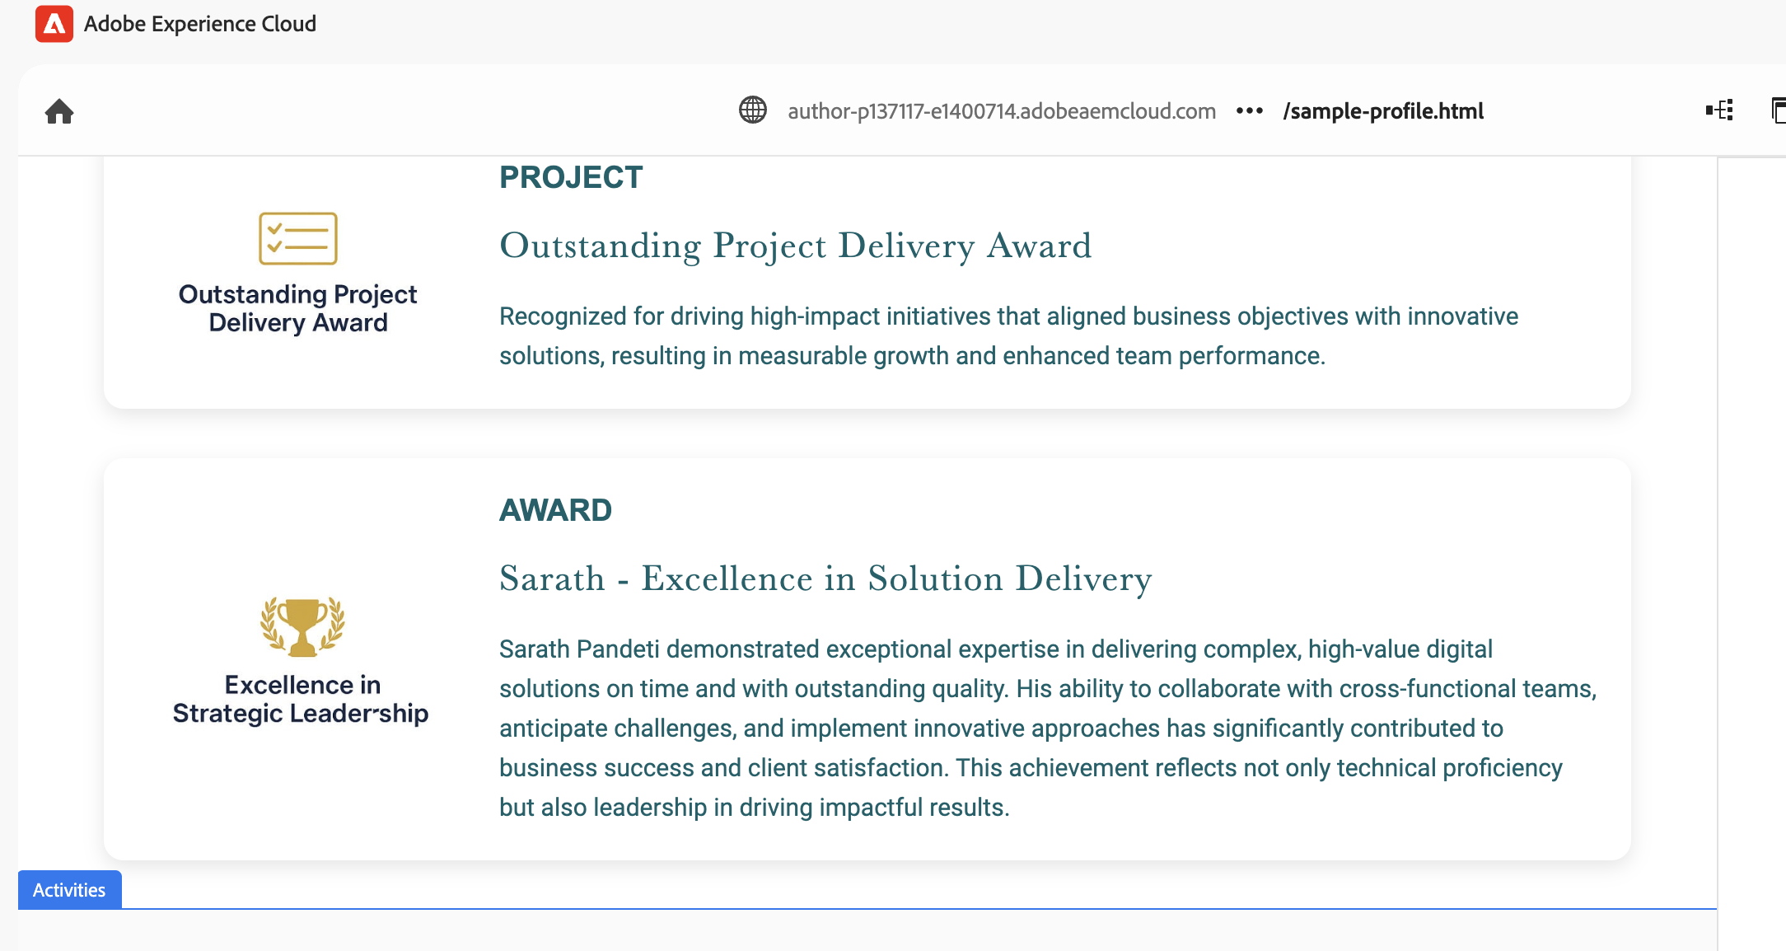

6. Update content/add for **Activities Section/Block** by expanding the activities section and select the carousel slide and click on properties option to update it  
  
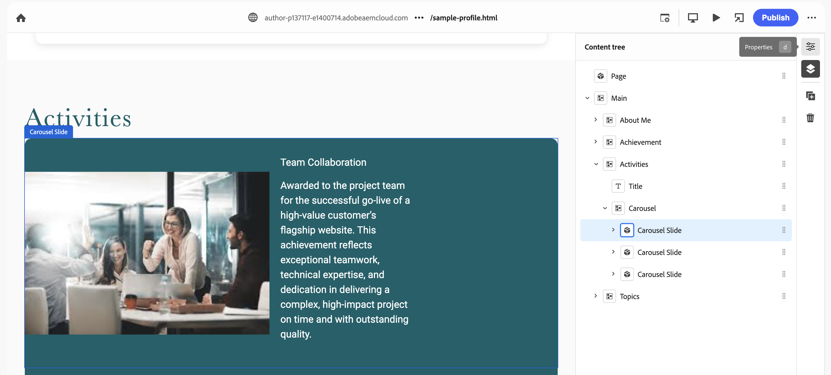

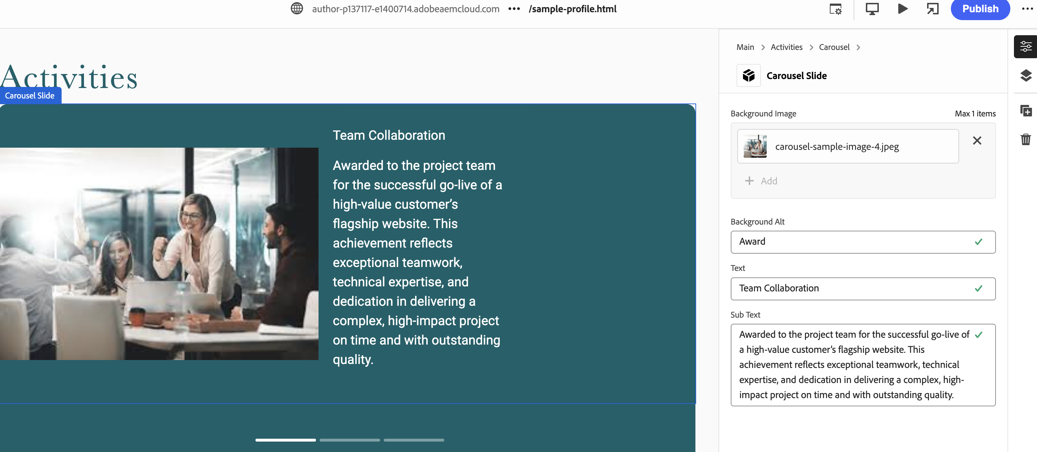

To create a new carousel slide, please select the **Carousel** and click on + Add icon on the right navigation bar, it will add a new carousel slide and update

In order to fill in the image on your new **Carousel**, please select the path by going to <AEM-Skill-Up< Execrise< Sample<Carousal or feel free to add you own image from your browser

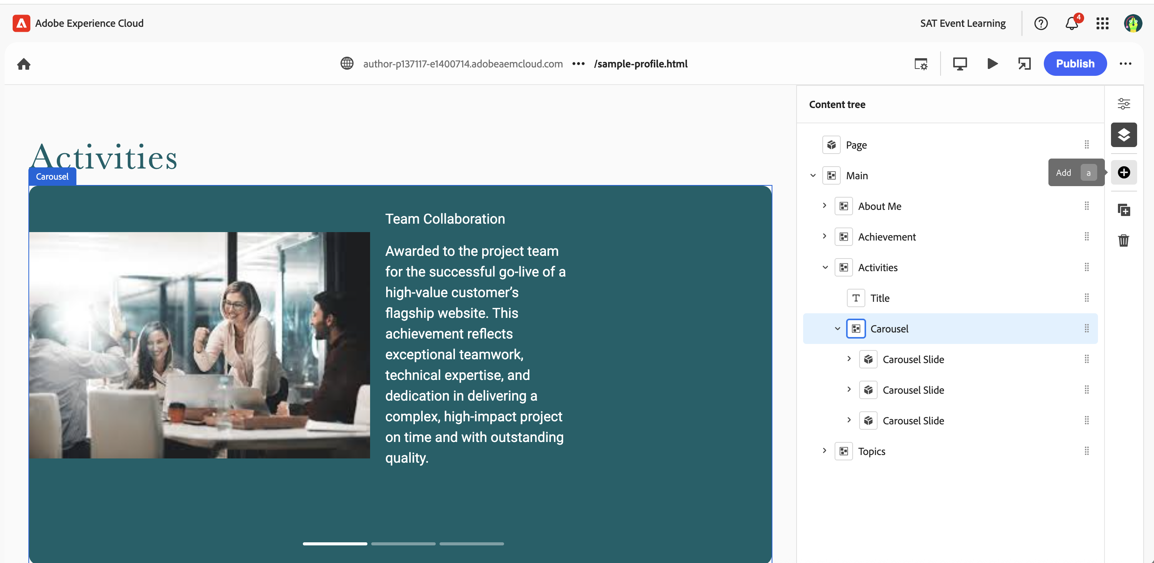

7. Adding further, to update the section related to **Topic & My View** section

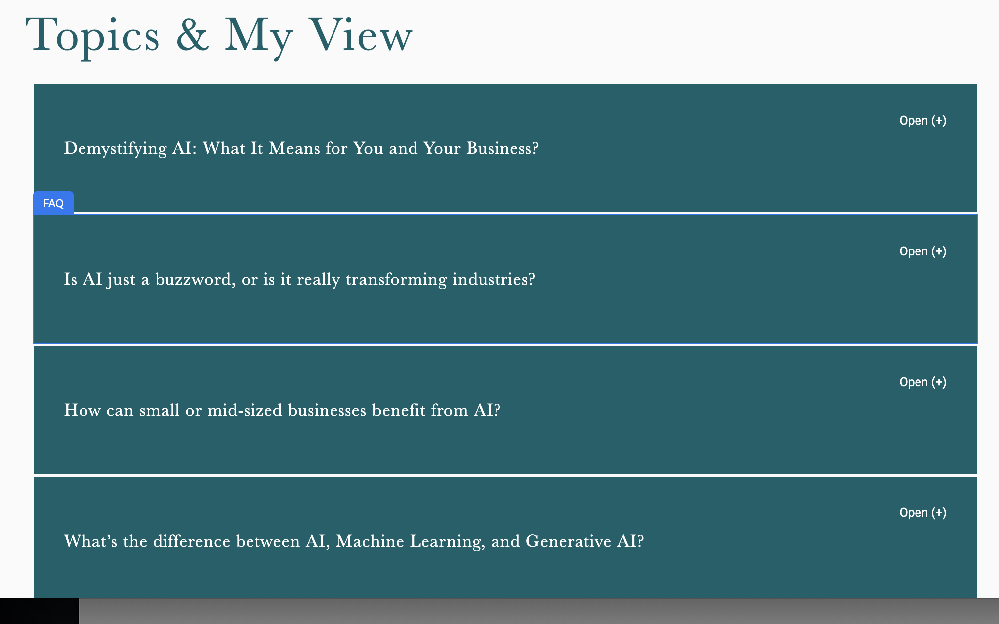

### 8. Update content/add for Topic & My View Section Block by expanding the Topics section and select the FAQ and click on properties option to update it

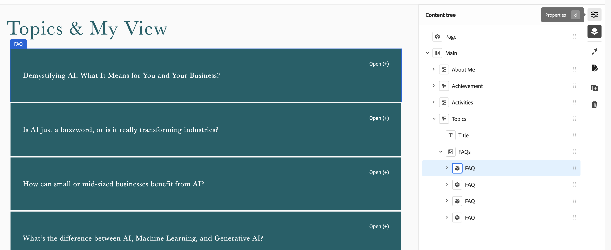

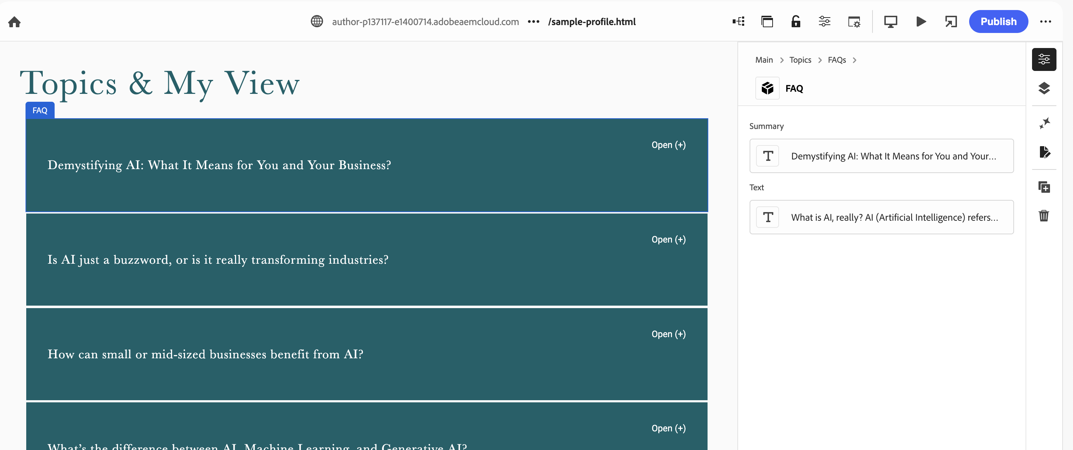

To create a **new FAQ**, please select the **FAQs** and click on + Add icon on the right navigation bar, it will add a new FAQ slide and then update the content as described in the previous step. **(select your own styling/layout option from the toolbar)**

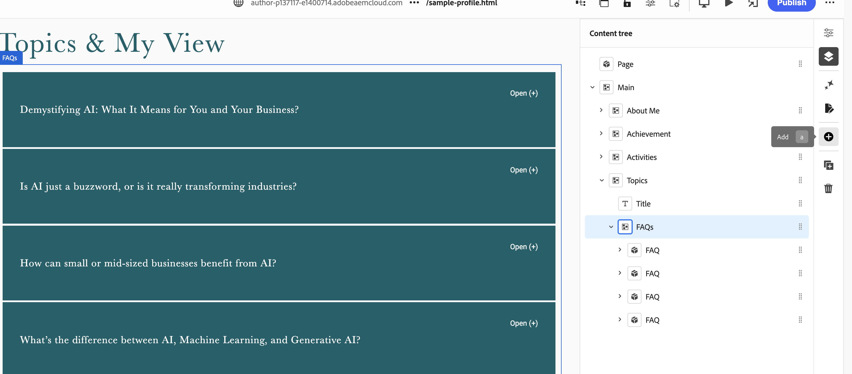

### 

### Part E – Review and Publish

1. You can publish the page using Universal Editor Publish option or using sites console.

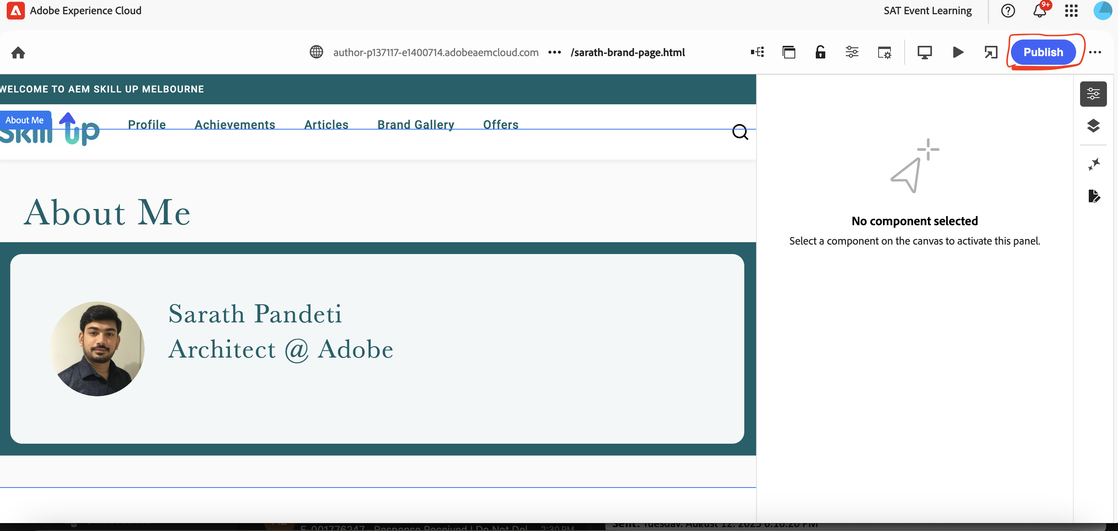

**Return to AEM Sites console → Select your page → Quick Publish.**  
  
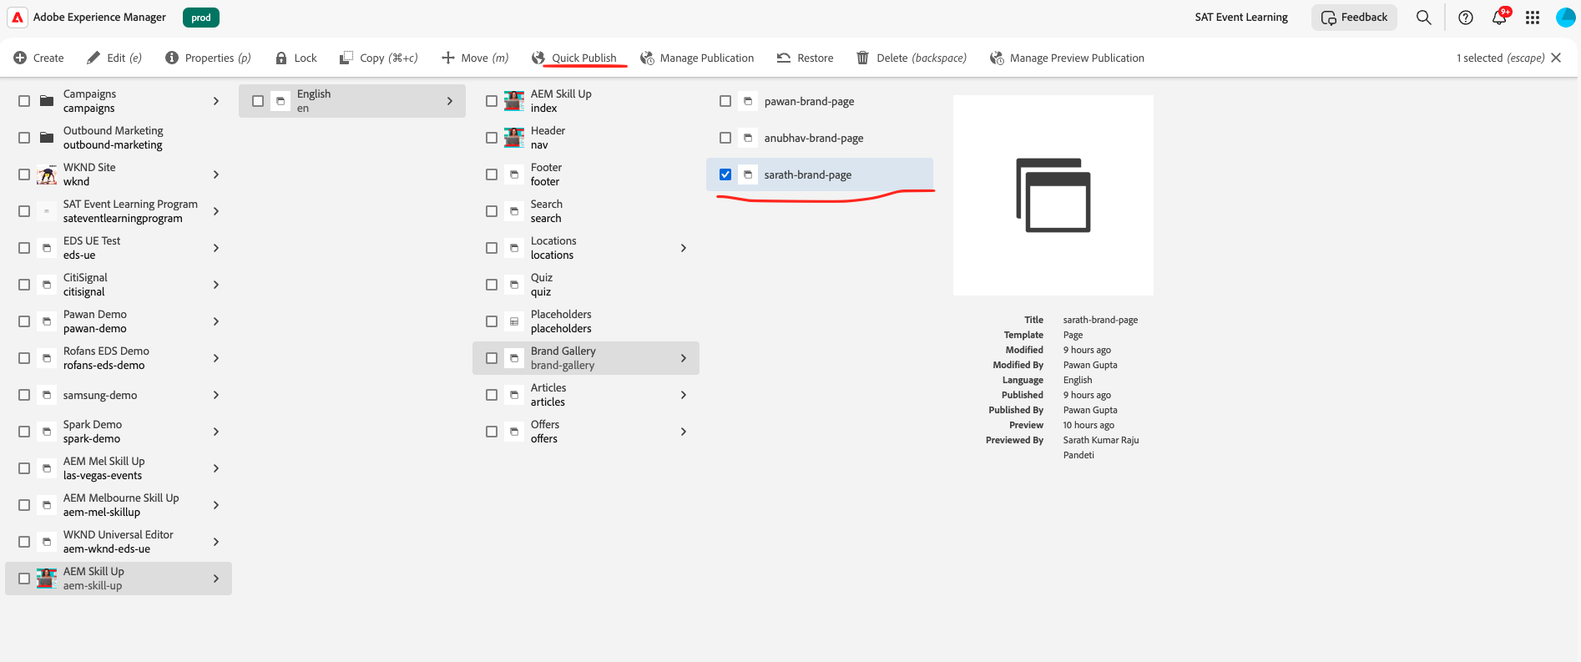

3. View your published page: <https://main--aem-skill-up--guptapawan86.aem.live/brand-gallery/pawan-gupta> ( replace pawan-gupta with your page name) Refer to the site page and use the hyphen name tag.

Once you able to view your page please go on the top bar and select **< Brand Gallery**> to see your profile with other members.

If you are unable to view your profile using the above link, please open the link in **Incognito mode.**

# Extra Activity

**Asset Upload Instructions:**

1. Click on Assets icon from start screen and navigate to “/content/dam/aem-skill-up/exercise” folder.  
  
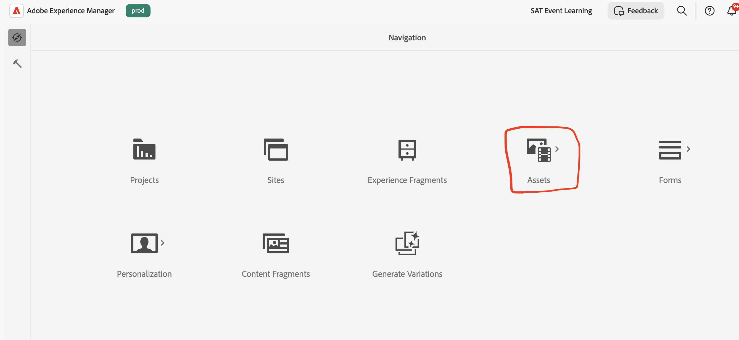

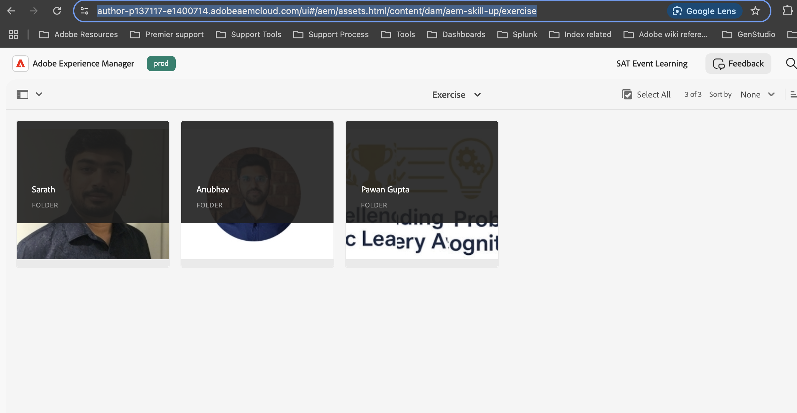

2. Create new folder and name your folder name.

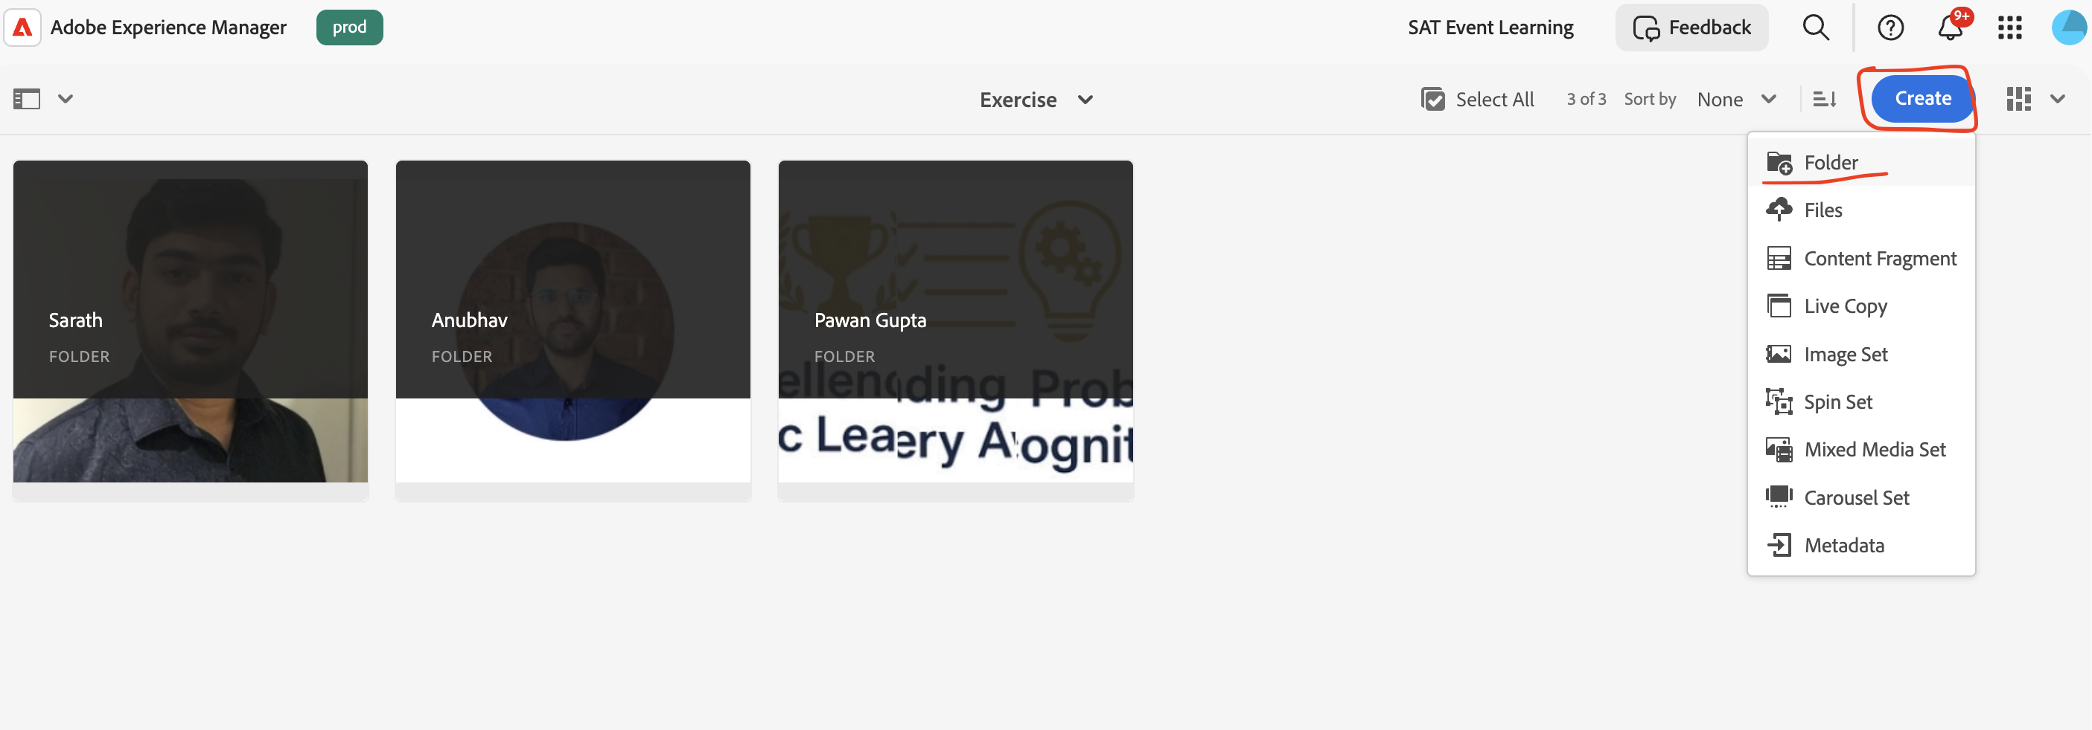

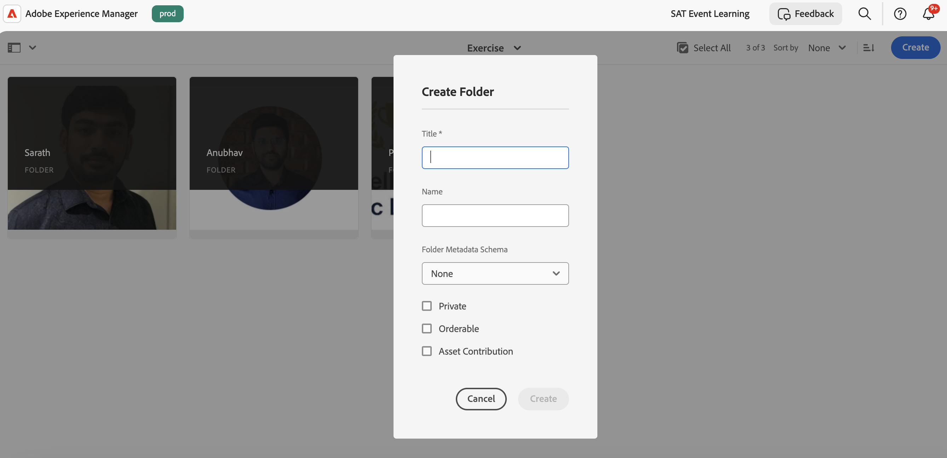

3. Upload the assets inside your folder by clicking create -> Files or using the upload option  
  
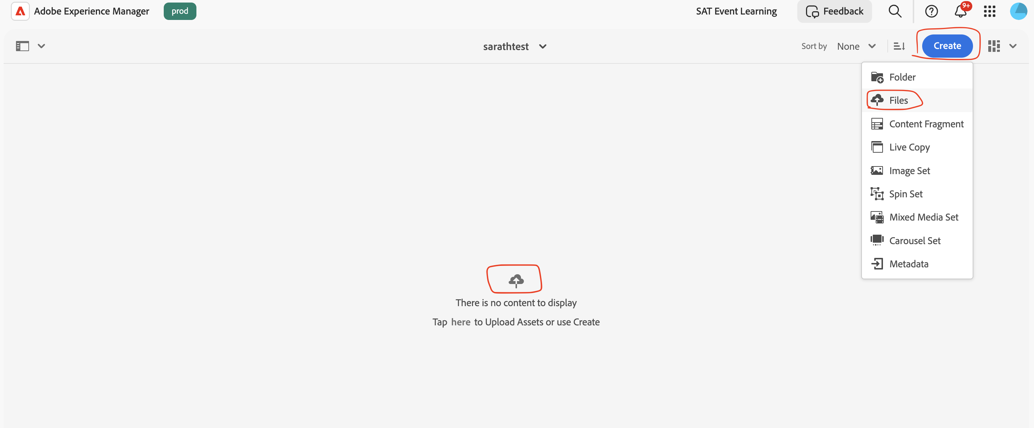

**Authoring content Fragments :**

1. Navigate to the assets folder created previously and click -> Create and choose Content Fragment



2. Choose Achievement Model and click Next and input the title and click create.  


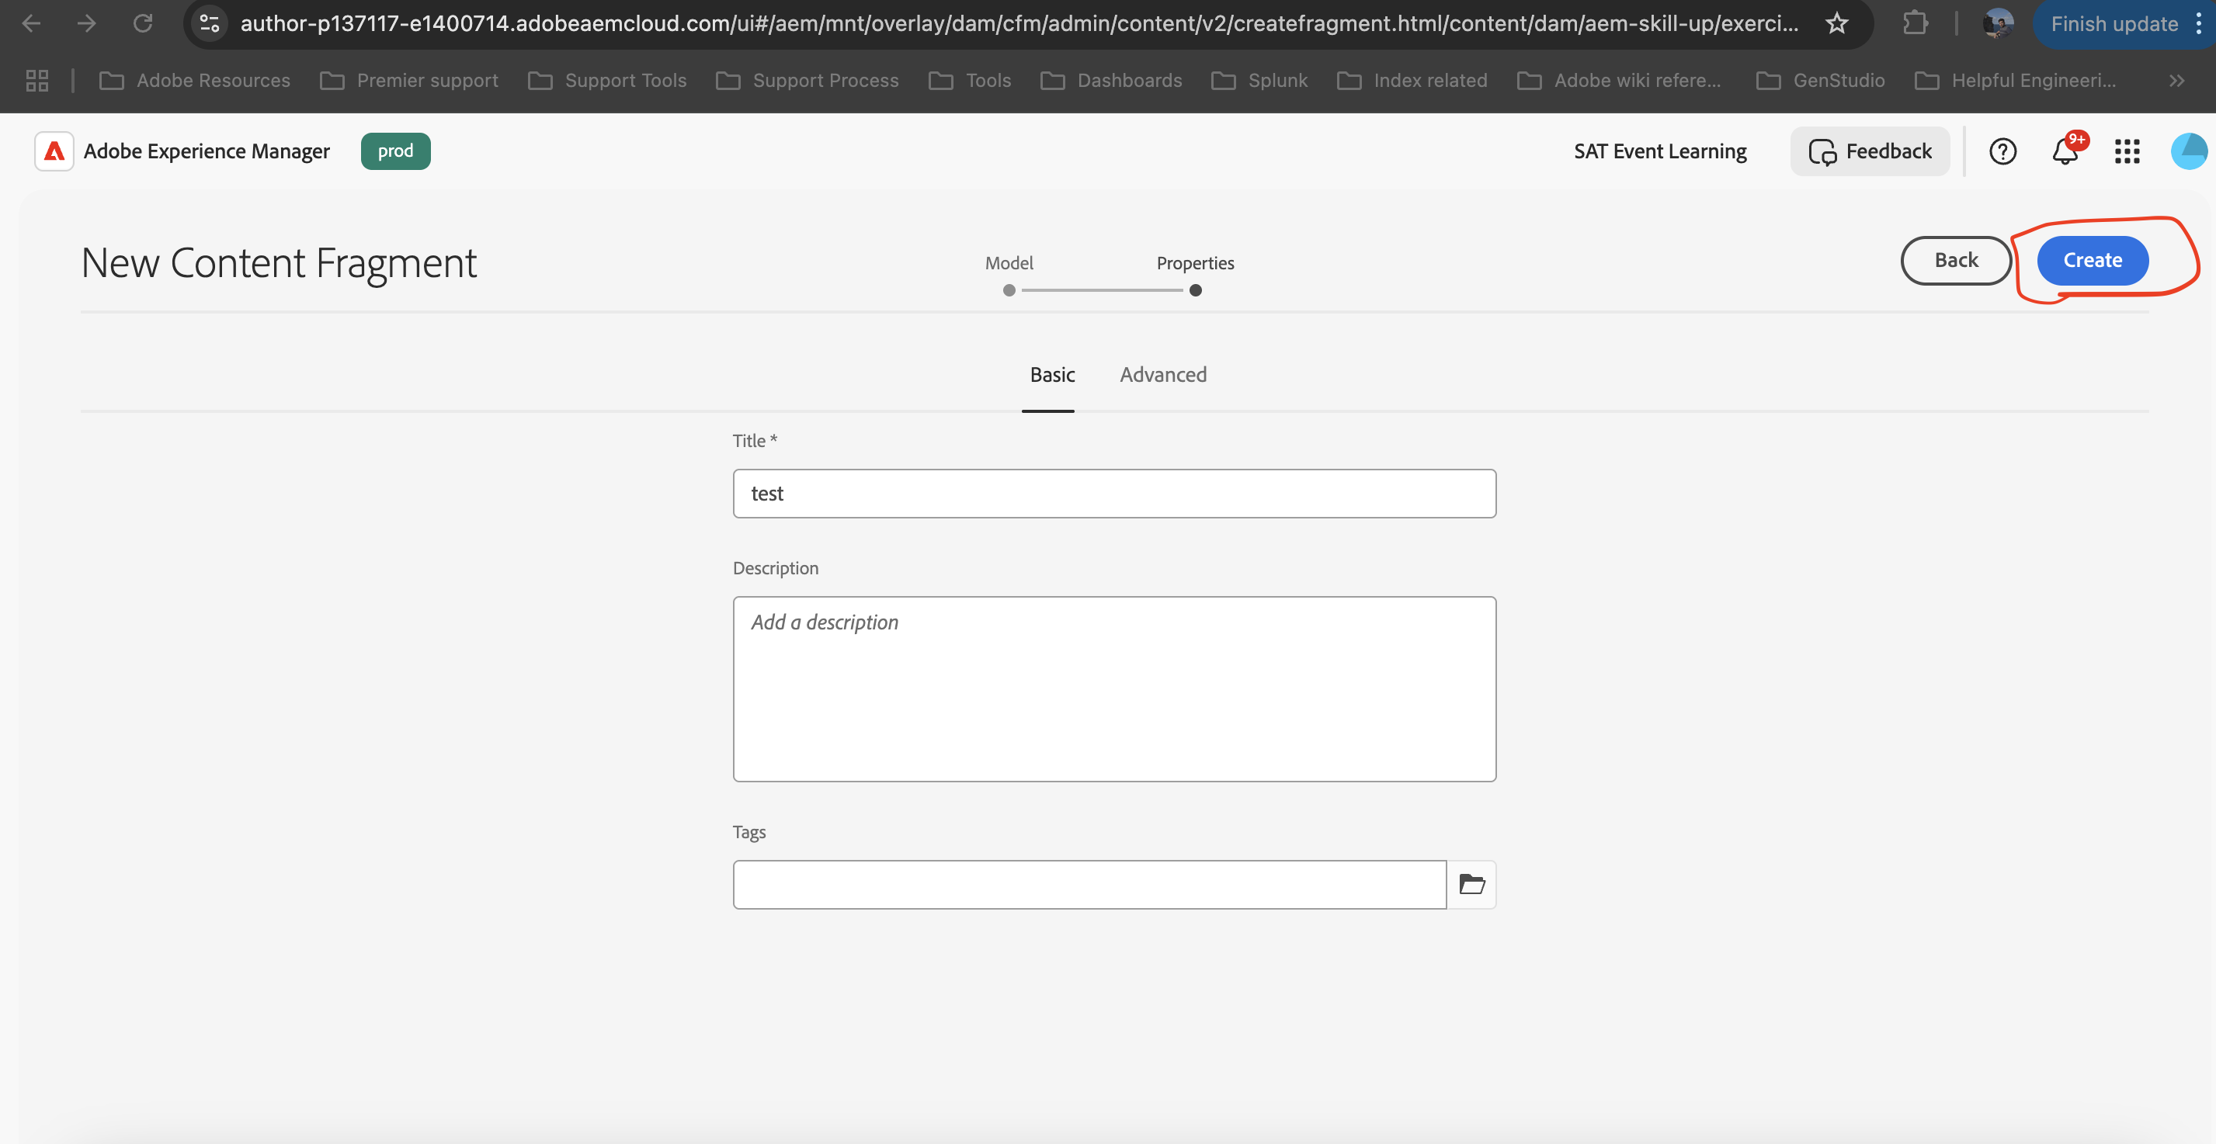

3. You will be shown a Success model popup and you can choose open and it will open the content model in a new window tab.  
  
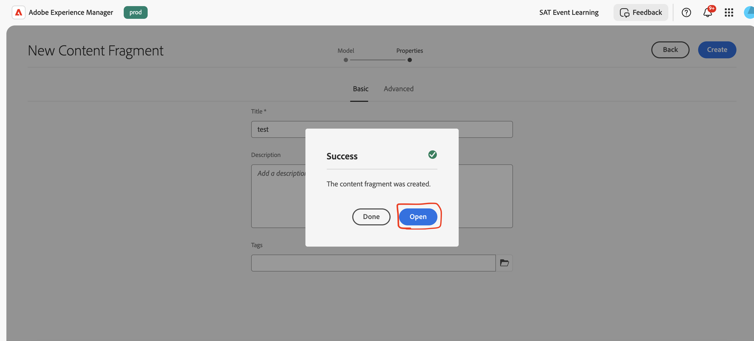

4. Input/Update the Achievement Title , Description & Achievement Image fields and click save.

For Achievement Image field navigate to the assets folder where you uploaded the assets and choose an asset  
  
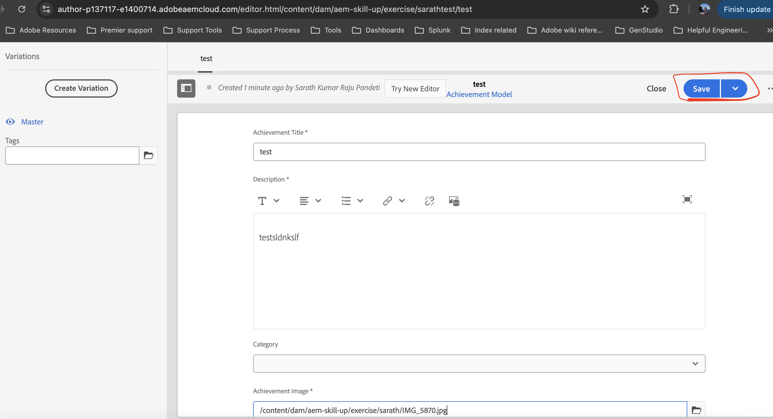

## Submission Requirement:

- Insert the screenshot from Part 1 (Lighthouse results) under the section below.  
- Provide the URL or screenshot of your personal brand page showing the hero block.

## Performance Results:

(Screenshot from Part 1 will be added here)

## Personal Brand Page Screenshot/URL:

(Screenshot or link from Part 2 will be added here)